RF and Microwave Design with JavaScript

Jerry Wiltz

Copyright © 2019 Jerry Wiltz

All rights reserved.

ISBN:

ISBN-13:

DEDICATION

For Marian, my Lúthien.

CONTENTS

|  |  |  |
| --- | --- | --- |
|  | Acknowledgments | i |
|  | Introduction |  |
| 1 | DC and Resistors | 1 |
| 2 | AC and Resistors, Inductors and Capacitors | Pg # |
| 3 | Chapter Name | Pg # |
| 4 | Chapter Name | Pg # |
| 5 | Chapter Name | Pg # |
| 6 | Chapter Name | Pg # |
| 7 | Chapter Name | Pg # |
| 8 | Chapter Name | Pg # |
| 9 | Chapter Name | Pg # |
| 10 | Chapter Name | Pg # |

ACKNOWLEDGMENTS

None.

1 DC and Resistors

This chapter begins with a review of DC theory and resistors. It reviews determining the total resistance of resistors in series: Rseries = R1 + R2 + R3 + …, it reviews determining the total resistance of resistors in parallel 1/Rparallel = 1/R1 + 1/R2 + 1/R3 + ... , and it reviews circuit analysis using voltage dividers. At this point, the arithmetic is straightforward. We will use all this review material to determine the resistance of a more complicated resistor network. So far, we are building on top what of the review material. Along the way, we review maximum power transfer, which is really the point of the whole thing.

All through this chapter, we will repeatedly analyze a resistor 3db attenuator 4 ways - all using DC theory. We do this to gain insight into network theory that is transferable to AC analysis. We will see that we can introduce the s-parameters at DC where the mathematics is much simpler and will set the stage to understand the s-parameters at AC with resistors, inductors, and capacitors covered in chapter 2.

We will analyze the 3dB attenuator using voltage dividers, using Kirchhoff’s Voltage Law, using Matrices, and finally using **nPort** all the while getting the same result. We perform hand calculations first to understand the theory better. After that, we see how simple it is to use **nPort** to accomplish the same thing. So we analyze by hand for learning and getting insight into circuit performance in order to use software, like **nPort**, knowing what to expect in advance.

**DC Review**

We start off with a basic circuit. This is the simplest circuit I can think of. It is shown in figure 1-1. It has a 1 volt DC source and a 1 Ohm resistor load. Note the current convention, current flows out of positive terminals of the source and moves in a clockwise direction.

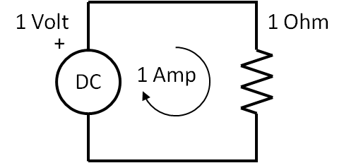

Figure 1-1 The Simplest Circuit

The current is 1 Amp from the equation. This is the **Ohm’s Law** equation.

|  |  |  |
| --- | --- | --- |
|  | $$I=\frac{V}{R}$$ | (1-1) |

For the values of V and R this this equation is very simple to solve as you mentally plug in 1 Volt over 1 Ohm to get 1 Amp.

Suppose there are two or more resistors are in series as shown in figure 1-2. We add them to determine Rseries

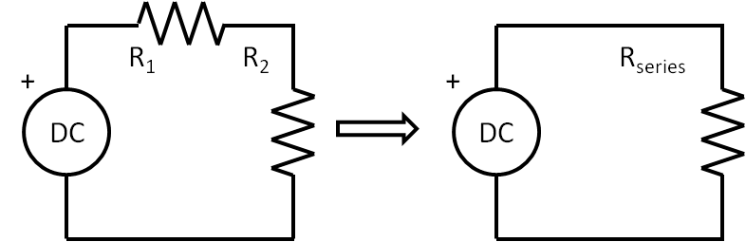

Figure 1-2 Resistors in series

The equation for the total resistance is the sum of all the resistors, and this is shown in equation 1-2.

|  |  |  |
| --- | --- | --- |
|  | $$R_{series}= R_{1}+ R_{2}$$ | (1-2) |

Likewise, if there are 2 or more resistors in parallel, as shown in figure 1-3, Rparallel now is inverse of the sum of the inverse of each resistor and is given by,

|  |  |  |
| --- | --- | --- |
|  | $$R_{parallel}= \frac{1}{\frac{1}{R_{1}}+\frac{1}{R_{2}}}$$ | (1-3) |

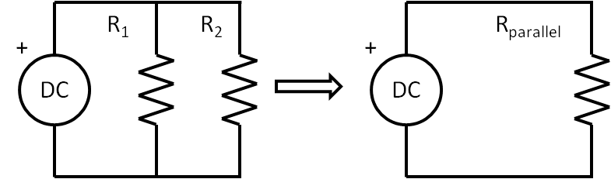

Figure 1-3 Resistors in parallel

Now we can determine the total resistance of a more complicated resistor network. A great many configurations of resistors can be combined into a single resistor by combining resistors that are in parallel and then adding to resistors in series. Keep doing this until there is one resistor left that is equivalent to the original network resistance, Requivalent. Take a look at the circuit shown in figure 1-4. You should work this out by hand to get insight and experience. You should work through them by hand at first.

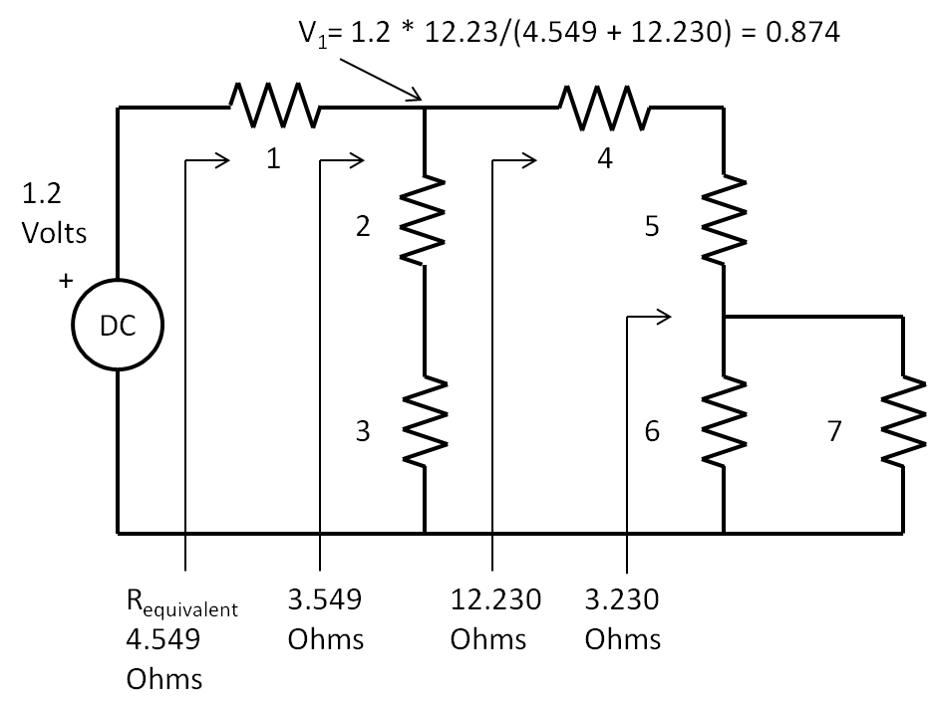

Figure 1-4 Finding the equivalent single resistor from seven resistors

Starting from the far right of figure 1-4, here are some steps to take:

* Parallel combine the resistors 6 Ω and 7 Ω together for 3.23 Ω
* Add that combination to the series resistors of 4 Ω and 5 Ω for 12.23 Ω
* Parallel combine that with the sum 2 Ω and 3 Ω for 3.549 Ω
* Add that to the 1 Ω for 4.549 Ω

I have included equivalent resistor values in figure 1-4, you should get those same results. Here is the result of an equation written on one line that does everything, Requivalent is 4.55 Ohms.

|  |  |  |
| --- | --- | --- |
|  | $$4.549=1+1/(1/(4+5+1/(1/6+1/7))+1/(2+3))$$ | (1-4) |

Look at this equation and map the resistor values to the figure. You can see the parallel combination of the 6 and 7 Ohm resistors, then summing that with the 4 and 5 Ohm resistors, then putting that in parallel with the two series resistors of 2 and 3 Ohms, and finally adding that result with the series 1 Ohm resistor. Open up a browser such as Chrome. Then copy and paste the following into the search field: 1 + 1/( 1/(4 + 5+ 1/(1/6+1/7)) + 1/(2 + 3)). This wakes up the calculator that is part of the browser and boom, there is the result of 4.5591 Ohms. Pretty cool.

**Maximum Power Transfer**

Now we introduce the concept of Maximum Power Transfer from a source to a load. In the circuit shown in figure 1-5, the source is located inside the dotted line box that also contains a series resistor that is the internal resistance of the source. The load is connected across the terminals of the dotted line box. The load resistance value can be varied, say to a value lower than the internal resistor, or a higher value, or equal to the internal resistor value. We show these values in the table also in figure 1-6. This table has “educated guesses” for the load resistance and power is maximized when the load resistance is equal to the source resistance. So maximum power transfer occurs when **RSource = RLoad**. In the real world, there will always be a source resistance, no matter what, and power from the source will always be wasted and dissipated inside its own internal resistance. For now at DC, we define the value of the internal resistor to 50 Ohms. Power in an electrical circuit is the product of the voltage across a resistor and current flow through it. So for any resistor value, the power in Watts dissipated by it is,

|  |  |  |
| --- | --- | --- |
|  | $$P=V*I$$ | (1-5) |

As was mentioned, in the table of figure 1-5, there are some “educated guesses” of values of the load resistor, RLoad. The columns in the table show the value of load resistor and corresponding total current, the voltage across the load resistor and the power, in Watts, transferred to the load. The key observation that maximum power transfer occurs when the source resistance equals the load resistance. Notice the PLoad is greatest at RLoad = 50 Ohms and less than that if the RLoad is either less than or greater than 50 Ohms. Note also, if the source resistance is 50 Ohms, the load resistance must be 50 Ohms. Maximum power transfer is a fundamental concept in RF and microwave design.

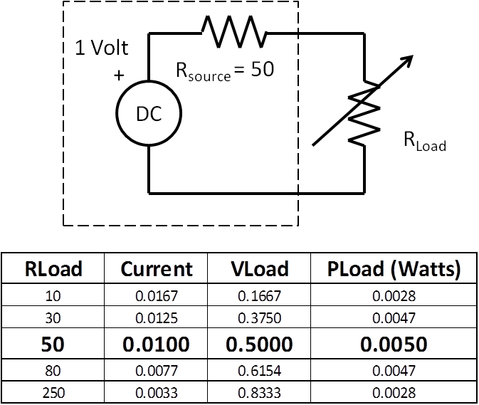

Figure 1-5 Maximum Power Transfer demo with “educated guesses” of load resistor values

Now we introduce the Through 2-port as shown in figure 1-6. Electrically, it is no different than the maximum power transfer circuit shown in figure 1-5. The circuit shown in figure 1-6 is a simple modification of figure 1-5. In this case, the Through 2-Port was inserted between the source and the load. The Through 2-port has four terminals, two terminals for each port. So for circuit with n number of ports, it has 2n terminals. With the Through 2-port in place, maximum power is transferred. As we proceed in this and the next chapters, we will replace the Through 2-port with more complicated 2-ports

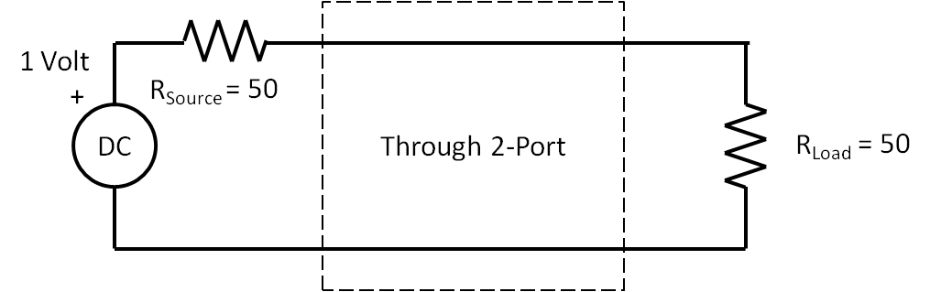

Figure 1-6 Showing the very simple Through 2-port, Power transfer is maximized.

What is the voltage at the load resistor in the circuit of figure 1-6? It is 0.5 Volts, right? Since the resistors are equal and in series, the same current flow through them and therefore they each have same voltage spread across them. There is a simple equation for this. This is the voltage divider equation.

|  |  |  |
| --- | --- | --- |
|  | $$V_{Load}=V_{Source}*\frac{R_{Load}}{R_{Source}+R_{Load}}=1*\frac{50}{100}=0.5V$$ | (1-6) |

**The Decibel**

Historically, back in the days of the early telephone, and due to the large range of the ratios of power gains and losses of telephone transmission lines and systems, it became more practical to plot on paper these ratios with log scales. In honor of Alexander Graham Bell, the unit for this log of ratios was named the ***bel.*** To make the plotting even easier the ***bel*** was multiplied by 10 to give the new unit, the ***decibel.*** A decibel is defined as one tenth of a bel. That’s why we multiply by 10. Now why did we multiply by 20 in equation 1-11 instead of 10? The decibel is 10 * log of a power ratio. But the ratio in equation 1-11 is a voltage ratio. Since these are voltages across resistors, we need to obtain the power dissipated by the resistors. Since,

|  |  |  |
| --- | --- | --- |
|  | $$I=\frac{V}{R}$$ | (1-7) |

and,

|  |  |  |
| --- | --- | --- |
|  | $$P=V*I$$ | (1-8) |

therefore,

|  |  |  |
| --- | --- | --- |
|  | $$P=V*\frac{V}{R}=\frac{V^{2}}{R} Watts$$ | (1-9) |

Notice that V squared in the numerator, taking the log of a number raised to a power, the power multiplies the log of the base.

|  |  |  |
| --- | --- | --- |
|  | $${10*log}_{10}\left({4.52}^{2}\right)=2*10*\log_{10}\left(4.52\right)=20*\log_{10}\left(4.52\right)$$ | (1-10) |

So just remember, when dealing with voltages, use 20*log, when dealing with powers, use 10*log. For far more info check the wiki page on the [decibel](https://en.wikipedia.org/wiki/Decibel).

If you think of an RF system as blocks chained together and each blocks has either a gain or a loss, then you could determine the overall gain or loss by multiplying all the individual stages together. But that is really messy. Much easier to use dB’s because we add them rather than multiply them, the log of multiplied numbers is equal to the addition of the log of each stage. Suppose there is a very simple RF system that has two blocks. The first block is an amplifier with a gain of 177. The second block is long cable that has a loss of 0.707. The overall gain is 177 times 0.707 = 125. But look,

|  |  |  |
| --- | --- | --- |
|  | $$20*\log_{10}\left(177*0.707\right)=20*\log_{10}\left(177\right)+20*\log_{10}\left(0.707\right)$$ | (1-11) |

Or

|  |  |  |
| --- | --- | --- |
|  | $$42dB=45dB-3dB$$ | (1-12) |

Suppose there are dozens of blocks to make up an RF system. It is much easier thinking in dB’s and adding than thinking of multiplying huge or tiny number together.

One of the things seasoned RF types could do is dB arithmetic in their heads. It takes a little memorization and practice and the memorization part is knowing the logs of x=1 through x=10 by heart shown in the table below.

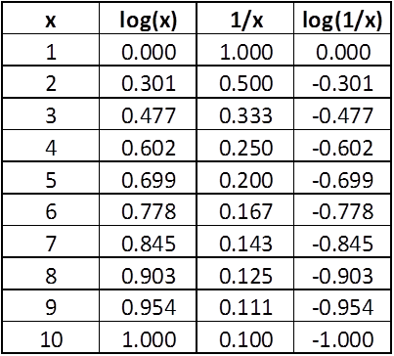

So let’s redo the amplifier gain of 177 and cable loss of 0.707, quickly and approximately in our head, assuming we have memorized and practiced. For the amplifier gain, 177 is 1.77 * 100, so using the memorized table 1.77 is close to 2 and the log of 2 is close to 0.3; the log of 100 is 2, so we add the logs 0.3 to 2 to get 2.3 and then multiply by 20 to get 46 dB gain for the amplifier. Similarly for the cable loss, 0.707 is 7 * 1/10, so the log of 7 is about 0.8 and the log of 1/10 is -1.0, obtaining the sum of 0.8 - 1.0 to get -0.2 and multiply by 20 to get -4 dB loss for the cable. Lastly, to obtain the overall gain of this RF system we add 46 dB to - 4 dB to get 42 dB. It is the same result as in equation (1-17). So, by expressing large or small numbers as a number between 1 and 10 with multiples of  10 or 1/10, (This is called scientific notation) using logs we can reduce long chains of multiplication to simpler chains of addition. The decibel is used all over the place in RF and Microwave.

**The 3dB Attenuator**

Figure 1-7 shows the schematic of a 3dB attenuator that we will analyze by five methods. The point of this is to keep things simple and build up from there. The methods are: the voltage divider method by hand, and then by Kirchhoff’s Voltage Law using JavaScript only, and then by Kirchhoff’s Voltage Law with power waves, and then using **nPort** matrix methods, and lastly by using **nPort**’s-parameter methods.

**The 3dB Attenuator solution #1 of 5:**

**The voltage divider method**

One of goals of this chapter is to analyze this circuit for attenuation by hand and then by JavaScript. Additionally, spending time with the hand analysis is vital because that is what will train you to understand what is happening. It’s like learning to cook, you have to cook and experience the way food comes together, only then can you create brand new dishes. Similarly, you have to experience how the equations work, only then can create brand new circuits. Moreover, working through things by hand at first will give you insight and will give you a notion of what to expect rather than blindly using computers and software while being unaware of what to do next when you don’t get expected results. So we will begin, first, to analyze the 3dB attenuator circuit shown in figure 1-7.

We start the hand analysis of the 3dB attenuator by using the voltage divider technique. The voltage divider formula is shown in equation 1-6.

* Combine R1, R2, R3, and RLoad into one resistor, RV1.
* Plug V=1, RSource and RV1 into the voltage divider equation 1.6 and find V1
* Combine R3 and RLoad into one resistor, RV2
* Plug V1, R2, and RV2 into the voltage divider equation 1-6 and find V2
* Take 20*log(V2/V1) to compute the attenuation of 3dB.

With these steps in mind, let us find the interior voltages V1 and V2 and the attenuation of the 3dB attenuator shown in figure 1-7.

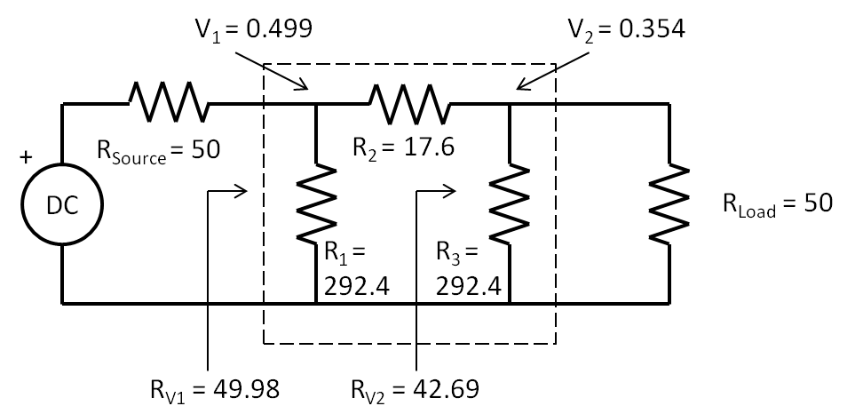

Figure 1-7 Schematic of a 3 dB Attenuator between a source and load

First, find RV1 given R1,R2,R3, and RLoad using the techniques of the resistance of a complicated circuit such that of figure 1.4.

|  |  |  |
| --- | --- | --- |
|  | $$R_{V1}=\frac{1}{\frac{1}{292.4}+\frac{1}{17.6+\frac{1}{\frac{1}{292.4}+\frac{1}{50}}}}=49.98Ω$$ | (1-13) |

Second, now we use the voltage divider equation to find V1

|  |  |  |
| --- | --- | --- |
|  |  | (1-14) |

Third, find RV2 by finding parallel resistance of R3 and RLoad

|  |  |  |
| --- | --- | --- |
|  |  | (1-15) |

Fourth, find V2 using the voltage divider equation and V1 along with R2 and RV2

|  |  |  |
| --- | --- | --- |
|  |  | (1-16) |

Lastly, plug in V1 and V2 into equation 1-17 to calculate the attenuation in dB.

|  |  |  |
| --- | --- | --- |
|  | $$20*\log_{10}\left(\frac{V_{2}}{V_{1}}\right)+20*\log_{10}\left(\frac{0.354}{0.499}\right)=-2.997dB$$ | (1-17) |

You should work through the above analysis by hand, get the same answers for V1,V2, and dB. Next, repeat the analysis, by hand for a 10dB attenuator having values of R1 = R3 = 96.25 Ohms and R2 = 71.15 Ohms. In this new situation, did you notice that V1 did not change? It is still 0.5 Volts. Why?

**The 3dB Attenuator solution #2 of 5:**

**Kirchhoff’s Voltage Law and JavaScript**

If you done the hand calculations thus far, you are realizing how tedious and mistake prone all this arithmetic can be. It would be great to mechanize this into forms that a computer could read and let a program to all the work. Since we are analyzing DC, the tedious analysis is performed only one time. However when we are analyzing AC, the analysis must be performed for each frequency point, so computer solutions are even more important.

So now we begin to form a foundation for the mechanization of these analyses and using computer and software. First, we will introduce Kirchhoff’s Voltage Law identifying and setting up the loop currents and voltage drops across resistors. Second, will introduce the resistor matrix to solve for currents and use JavaScript to do the arithmetic. Third, we will use the currents to solve for the voltages of interest and take their ratios. Lastly, we will express these ratios in dB and get the same result as we did for the voltage divider technique.

Starting with Kirchhoff’s Voltage Law: for a closed loop series path the algebraic sum of all the voltages around any closed loop in a circuit is equal to zero. In figure 1-8, there is one closed current loop and the Kirchhoff’s Voltage Law equation for this situation is

|  |  |  |
| --- | --- | --- |
|  | $$V-I*R=0$$ | (1-18) |

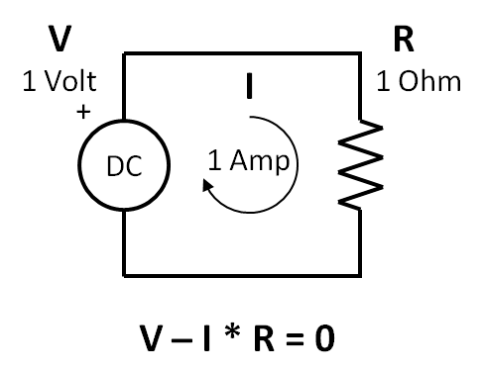

Figure 1-8 Simple schematic showing Kirchhoff’s Voltage Law.

Listing 1.1 below shows JavaScript in the body section of an html page. You should create a file named index.html and camp there until can see the 1 Amp result for the current, I, in the console window. **Make sure you can do all of this before going further.** You should get this listing to run in your browser and see the output in the console of your browser. Now would be a good time to learn you to use some of the console. I use YouTube a lot to learn about these things. So have at it.

Listing 1-1 Simple JavaScript and Kirchhoff’s Voltage Law.

// Kirchhoff voltage law

var R = 1, V = 1, I = 0;

I = V/R;

console.log('The loop current is ...');

console.log(I + ' Amp');

Do you know how to use the console in your browser now? From now on, I am assuming you know how.

Next, and knowing how to observe JavaScript results on console of the browser, we will analyze the 3 dB attenuator again. Let us apply Kirchhoff’s Voltage Law to the 3 dB Attenuator first shown in figure 1-8. We redraw it in figure 1-10 to show the three current loops and apply Kirchhoff’s Voltage Law three times, one for each loop.

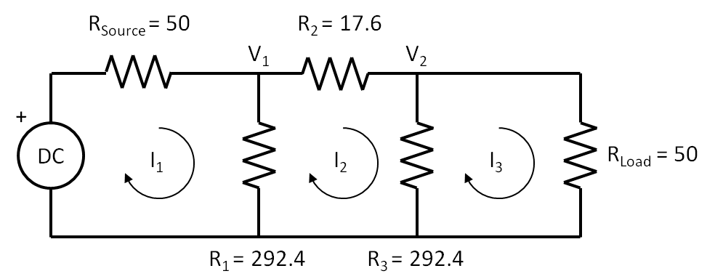

Figure 1-9 3dB Attenuator analysis using Kirchhoff’s Voltage Law

Here is Kirchhoff’s Voltage Law for the first current loop,

|  |  |  |
| --- | --- | --- |
|  | $$V{-I}_{1}*R_{Source}{-I}_{1}*R_{1}+I_{2}*R_{1}+I_{3}*0=0$$ | (1-19) |

Regarding order of operations, multiplication is done first then addition or subtraction is done next. Thus we **do not** perform *V-I1* in equation 1-19. Remember the mechanics here, look at the first current loop, all the voltages have to sum to zero. The sign of the current, I1, is negative, but the sign of I2 is positive, since I2 flows in the opposite direction of I1. I3 is listed for completeness, since there is no common resistor between I1 and I3, I3 has no impact on the first current loop. Also, remember the order of operations, you multiply first, then add. Lastly, note that V will be a known variable, but I1, I2, and I3 are unknown variables. In order to solve for each unknown, we will need three equations containing the three unknowns. Equation 1-19 is the first equation.

Next, apply Kirchhoff’s Voltage Law to the second current loop,

|  |  |  |
| --- | --- | --- |
|  | $$0{+I}_{1}*R_{1}{-I}_{2}*R_{1}-I_{2}*R_{2}-I_{2}*R_{3}-I_{3}*R_{2}=0$$ | (1-20) |

Next, apply Kirchhoff’s Voltage Law to the third current loop,

|  |  |  |
| --- | --- | --- |
|  | $$0{+I}_{1}*0+I_{2}*R_{3}-I_{3}*R_{3}-I_{3}*R_{Load}=0$$ | (1-21) |

So the three equations, 1-19, 1-20, and 1-21 of Kirchhoff’s Law:  
V-I*R=0. The next step is to put them into the form of:  
V=R*I, and we use algebra for this. I put the results all together in equation 1-22 below.

|  |  |  |
| --- | --- | --- |
|  | $$\begin{matrix}V= & \left(R_{Source}+R_{1}\right)*I_{1} & {-R}_{1}*I_{2} & 0*I_{3} \\ 0= & {-R}_{1}*I_{1} & {(R}_{1}+R_{2}+R_{3})*I_{2} & {-R}_{3}*I_{3} \\ 0= & 0*I_{1} & {-R}_{3}*I_{2} & \left(R_{3}+R_{Load}\right)*I_{3}\end{matrix}$$ | (1-22) |

Look at the first line of equation 1-22. There are 2 resistors that carry I1: RSource and R1 and there is an adjacent current loop carrying I2 through the common resistor, R1. Note again, I2 is flowing opposite I1 and the actual current through R1 is I1-I2. Also notice that each equation must contain terms that have all three currents. I1 and I2 matter in the first line of equation 1-22, but not I3 since the first and third loops do not touch. In the second line in equation 1-22, all the currents matter since loop2 is adjacent to loops 1 and 3.

So finally, let's put equations 1-22 in matrix form of **V = R * I** and the result is shown in equation 1-23.

|  |  |  |
| --- | --- | --- |
|  | $$\left[\begin{matrix}V \\ 0 \\ 0\end{matrix}\right]=\left[\begin{matrix}R_{Source}+R_{1} & -R_{1} & 0 \\ -R_{1} & R_{1}+R_{2}+R_{3} & -R_{3} \\ 0 & -R_{3} & R_{3}+R_{Load}\end{matrix}\right]*\left[\begin{matrix}I_{1} \\ I_{2} \\ I_{3}\end{matrix}\right]$$ | (1-23) |

It is important to compare equations 1-22 to 1-23. See the currents shown in equation 1-22 map over to the currents shown in equation 1-23. Regarding terminology, on the far left of the equation is the 3 by 1 Voltage Matrix. On the far right of the equation is the 3 by 1 Current matrix. In the center of the equation is the 3 by 3 Resistor Matrix. So this say that the voltage matrix is equal to the resistor matrix multiplied by the current matrix. Examine the R matrix shown by itself in equation 1-24. The resistors are positive along the diagonal. This is always the case. Also note all the other resistors are negative, again this is always the case. Common resistors are always negative and are symmetrical about the diagonal. This always the case as well. Since the R matrix is so predictable, it can be formed by inspection. This is important. No need for all the equations and algebra and all the rest. Follow the rules to form the R matrix, then stick the voltages on the left, and the currents on the right and you have it.

|  |  |  |
| --- | --- | --- |
|  | $$R=\left[\begin{matrix}R_{Source}+R_{1} & -R_{1} & 0 \\ -R_{1} & R_{1}+R_{2}+R_{3} & -R_{3} \\ 0 & -R_{3} & R_{3}+R_{Load}\end{matrix}\right]$$ | (1-24) |

Now all we have to do is to solve for I, given V and R.

Referring to the 3dB attenuator shown in figure 1-9, the reason we need to know the currents I1, I2, and I3 is to find the voltages V1 and V2 which are across R1 and R3 respectively. Here are the equations for V1 and for V2,

|  |  |  |
| --- | --- | --- |
|  |  | (1-25) |

|  |  |  |
| --- | --- | --- |
|  |  | (1-26) |

Solving matrices by hand is tedious and error prone. I always make a little mistake, no matter how careful I am. Then I have to go back and find it and fix it. It is much better to have the computer do it. But we will cover the basic theory first. We will use **Cramer’s Rule** and JavaScript to solve for I1, I2, and I3. If unfamiliar with Cramer’s Rule, you can look it up on YouTube and find out more about it. So here is Cramer’s Rule for the solution for I1,

|  |  |  |
| --- | --- | --- |
|  |  | (1-27) |

So all we have to do is solve for the determinant of the numerator and divide it by the determinant of the denominator. There is a simple formula to obtain the determinant of a 3 by 3 matrix, given the matrix, A, in equation 1-27,

|  |  |  |
| --- | --- | --- |
|  | $$A=\left[\begin{matrix}a_{11} & a_{12} & a_{13} \\ a_{21} & a_{22} & a_{23} \\ a_{31} & a_{32} & a_{33}\end{matrix}\right]$$ | (1-28) |

For the R matrix, RSource + R1 = a11. Make sure you understand that. The determinant of matrix A is given by the formula in equation 1-28. Yes, this looks awful, but JavaScript will be used to solve the currents.

|  |  |  |
| --- | --- | --- |
|  | $$Determinant of A =a_{11}*a_{22}*a_{33}+a_{12}*a_{23}*a_{31}+a_{13}*a_{21}*a_{32}-a_{31}*a_{22}*a_{13}-a_{32}*a_{23}*a_{11}-a_{33}*a_{21}*a_{12}$$ | (1-29) |

We follow the same procedure for I2 and I3, or

|  |  |  |
| --- | --- | --- |
|  |  | (1-30) |

|  |  |  |
| --- | --- | --- |
|  |  | (1-31) |

We calculate the currents and then use equations 1-25 and 1-26 to find V1 and V2. Lastly we calculate 20log(V2/V1) for the attenuation, in dB.

In the listing 1.2, all the formulas for current have the same denominator, D and is solved once and used three times. The three numerators are different and are named, I1D, I2D, and I3D. So each current is I1=I1D/D, I2=I2D/D, and I3=I3D/D. Once I1, I2, and I2 are known, then V1 and V2 can be determined and the 20log(V2/V1) is calculated.

Let’s solve for I1 using equations 1-26 and 1-28. We set V equal to one volt, and plug in the values of the resistors in the 3dB attenuator as shown back in figure 1-10.

|  |  |  |
| --- | --- | --- |
|  | $$I_{1}=\frac{\left[\begin{matrix}1 & -292.4 & 0 \\ 0 & 602.4 & -292.4 \\ 0 & -292.4 & 100\end{matrix}\right]}{\left[\begin{matrix}100 & -292.4 & 0 \\ -292.4 & 602.4 & -292.4 \\ 0 & -292.4 & 100\end{matrix}\right]}=\frac{120764}{12075160} \\ =0.0100010264A$$ | (1-32) |

So I1 = 0.010 Amps. Listing 1.2 calculates the three currents and the two voltages and then computes the attenuation.

Listing 1.2 JavaScript listing.

// define the resistors

var Rsource = 50;

var R1 = 292.4, R2 = 17.6, R3 = 292.4;

var Rload = 50;

// function to compute the determinant

function determinant (a11, a12, a13,

a21, a22, a23,

a31, a32, a33) {

var out = a11*a22*a33

+a12*a23*a31

+a13*a21*a32

-a31*a22*a13

-a32*a23*a11

-a33*a21*a12;

return out;

}

// define the denominator, D

var D = determinant(Rsource+R1,-R1,0,

-R1,R1+R2+R3,-R3,

0,-R3,R3+Rload);

// find the numerators, I1D, I2D, I3D

var I1D = determinant(1,-R1,0,

0,R1+R2+R3,-R3,

0,-R3,R3+Rload);

var I2D = determinant(Rsource+R1,1,0,

-R1,0,-R3,

0,0,R3+Rload);

var I3D = determinant(Rsource+R1,-R1,1,

-R1,R1+R2+R3,0,

0,-R3,0);

// find the currents, I1, I2, I3

var I1 = I1D/D;

var I2 = I2D/D;

var I3 = I3D/D;

var V1 = R1*(I1 - I2);

var V2 = R3*(I2 - I3);

var attn = 20*Math.log10(V2/V1);

console.log('The attenuation is ...');

console.log(attn + ' dB');

**The 3dB Attenuator solution #3 of 5:**

**Kirchhoff’s Voltage Law and nPort Matrix Methods**

So for, we have analyzed the 3 dB attenuator two ways, the voltage divider technique and with Kirchhoff’s Voltage Law. The first way was a hand analysis with voltage dividers, the second way was a matrix analysis. Neither of these techniques required **nPort**. So now we introduce a third way by using **nPort** matrix functions. For very large circuits with a great loops, the matrices are too large for cramer’s rule and determinants. Large matrices can only be solved with computers with matrix methods. Equation 1-23 shown again equation 1-28 is

|  |  |  |
| --- | --- | --- |
|  | $$\left[\begin{matrix}V \\ 0 \\ 0\end{matrix}\right]=\left[\begin{matrix}R_{Source}+R_{1} & -R_{1} & 0 \\ -R_{1} & R_{1}+R_{2}+R_{3} & -R_{3} \\ 0 & -R_{3} & R_{3}+R_{Load}\end{matrix}\right]*\left[\begin{matrix}I_{1} \\ I_{2} \\ I_{3}\end{matrix}\right]$$ | (1-33) |

The general form of this matrix is,

|  |  |  |
| --- | --- | --- |
|  | $$\left[V\right]=\left[R\right]*\left[I\right]$$ | (1-34) |

Solving for [I],

|  |  |  |
| --- | --- | --- |
|  | $$\left[I\right]=\frac{\left[V\right]}{\left[R\right]}=\left[V\right]*{\left[R\right]}^{-1}$$ | (1-35) |

Where [R]-1 is called the **inverse** of [R]. Once we have[R]-1, all we have to do to calculate the current is to multiply the voltage matrix, [V] by [R]-1 to obtain the currents. In this next listing, **nPort** will be used to solve perform matrix operations. First, we define the [R] matrix. Second, we define the [V] matrix. Third, We produce, [R]-1 with the **nP.invert()** method. Fourth, we obtain the [I] matrix by multiplying the inverted [R] matrix by the [V] matrix in the matrix **nP.mul()** method. All of these steps are shown in listing 1.3. Create listing 1.3 named index.js and run it. Examine the object, i, with the console and see what object members and methods are. In an nP.matrix object, there is only one member and its key name is “m” and its data is a JavaScript array of arrays. Each row of the matrix is an array.

Listing 1.3 using nPort matrix methods.

// define the resistors

var Rsource = 50;

var R1 = 292.4, R2 = 17.6, R3 = 292.4;

var Rload = 50;

// define the resistor matrix

var r = nP.matrix( [

[Rsource + R1, -R1 , 0 ],

[-R1 , R1 + R2 + R3, -R3 ],

[0 , -R3 , R3 + Rload],

] );

// define the voltage generator matrix

var v = nP.matrix( [

[1],

[0],

[0],

] );

// find the inverse of the resistor matrix

var rInvert = r.invert();

// find the current matrix by multiplying

var i = rInvert.mul(v);

var V1 = R1*(i.m[0] - i.m[1]);

var V2 = R3*(i.m[1] - i.m[2]);

var attn = 20*Math.log10(V2/V1);

console.log('The attenuation is ...');

console.log(attn + ' dB');

**Basketball and the Scattering Parameters**

For those who have never heard of s-parameters and are new to RF, here is a basketball analogy for RF transmission and s-parameters. According to this analogy, the basketball is the input voltage and the rim is the RF circuit. Also, according to this analogy, we consider only three cases. The best shots don’t touch the rim and go through, this is case 1. Uglier shots touch the rim and go through, this is case 2. Missed shots bounce off the rim and don’t go through, this is case 3.

If the ball goes through the rim as in case 1, we could say that is was **transmitted** through the hoop. If the ball touches the rim as in case 2, we could say that it was also transmitted, but has lost some energy. If the ball misses in case 3, we could say that it was **reflected** back off the hoop.

In case 1, there is complete transmission and no reflection. In case 2, there is mostly transmission with some reflection. In case 3, there is no transmission and complete reflection.

Consider case 2: There is a range a shots from less touching the rim to greater touching the rim. At the high end of the range, there is greater transmission and lesser reflection. At the low end of the ranger, there is lesser transmission and greater reflection.

How do we represent these situations of the basketball? This will really sound strange, but this is what happens in the RF world. It is not called black magic for nothing. At the high end of the range, we could say that the basketball became a little smaller as it was transmitted, and say a new ping-pong ball is reflected back at the shooter. At the low end of the range, we could say that basketball became much smaller as it was transmitted, and that say a new baseball was reflected back to the shooter. As the transmitted basketball becomes smaller, the reflected ball gets bigger.

Now we name transmission and reflection coefficients as **τ**, “tau” and **ρ**, “rho” respectively, and define the range of their values from 0 to 1. Moreover, they are related to each other as τ goes up ρ goes down, if τ is 1 ρ is 0 and vice versa**.** Here are our three cases again:

* In case 1, if τ = 1, then ρ = 0.
* In case 2, if τ is near 1, then ρ is near 0. If τ is near 0, then ρ is near 1.
* In case 3, if τ = 0, then ρ = 1.

All actual RF circuits operate in case 2. In development, the RF designer must maximize transmission and minimize reflection; or saying it another way maximize tau and minimize rho.

Now we introduce the s-parameters. Again, we will do this at DC because the math is much easier and when we transition to AC, we will have a better feel for what is going on. Figure 1-10a shows the 3dB attenuator. Figure 1-10b shows the same circuit but relabeled to conform to the definitions of the s-parameters. The electrical performance is the same for both schematics.

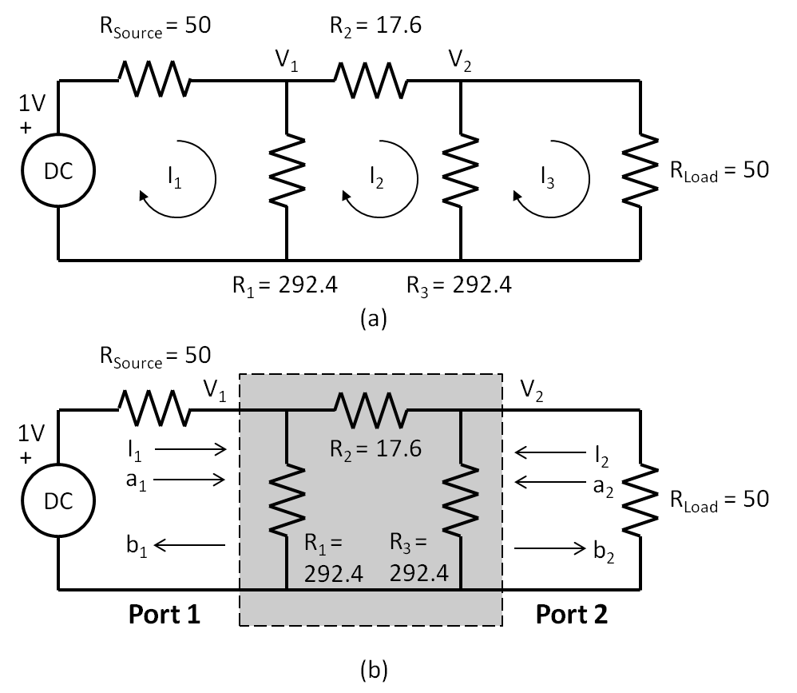

Figure 1-10 3dB Attenuator being analyzed as a 2-port

Some comments regarding figure 1-10. First, V1, V2, and I1 are the same for (a) and (b). Second, we do not know what is inside the shaded area in (b). Third, all we need to know are the currents and voltages at each port when terminated with RSource and RLoad. Fourth, I2 in (b) is the negative of I3 in (a). This is required because s-parameters are defined by current flow into a port. Fifth, we have introduced new variables **a** and **b** at each port. As we will see in a moment, **a** and **b** are related to V and I at each port. For s-parameters, the input to a port is **a**, and the output of a port is **b**. This is shown by the arrows for them in figure 1-10b. Note that a2 is 0 in this situation since there is no independent source at port 2. Back to the basketball analogy, a1 is the shot to rim, b1 is the ping-pong ball coming back, and b2 is the “smaller” basketball dropping through the rim.

|  |  |  |
| --- | --- | --- |
|  | $$s_{11}=\frac{b_{1}}{a_{1}}=rho$$ | (1-36) |

|  |  |  |
| --- | --- | --- |
|  |  | (1-37) |

But what is a1 and b1? They are related to V1 and I1 buy the following,

|  |  |  |
| --- | --- | --- |
|  | $$a_{1}=\frac{V_{1}+I_{1}*50}{2\sqrt{50}}; b_{1}=\frac{V_{1}-I_{1}*50}{2\sqrt{50}}; \\ a_{2}=\frac{V_{2}+I_{2}*50}{2\sqrt{50}}; b_{2}=\frac{V_{2}-I_{2}*50}{2\sqrt{50}}$$ | (1-38) |

What are the units for a1, b1, and b2? You can see that the units for the numerators in equation 1-38 are in Volts. Also, you can see that the denominators are in square root Ohms. This is shown below in equation 1-39. But now square a1 and now the units become watts per equation 1-9.

|  |  |  |
| --- | --- | --- |
|  | $$a_{1} =\frac{V}{\sqrt{Ω}} ; {a_{1}}^{2}= \frac{V^{2}}{Ω} Watts$$ | (1-39) |

For this reason, a and b waves are referred to in the literature as power waves.

**The 3dB Attenuator solution #4 of 5:**

**Using power waves a1 and b2 to determine s21dB**

Taking a look at figure 1-10, we have enough information to solve for s21 in dB form.

|  |  |  |
| --- | --- | --- |
|  | $$s_{21}=\frac{b_{2}}{a_{1}}=\frac{\frac{V_{2}-I_{2}*50}{2\sqrt{50}}}{\frac{V_{1}+I_{1}*50}{2\sqrt{50}}}; Standard Formula$$ | (1-40) |

But I3 is –I2, as we transition from figure 1-10(a) to 1-10(b)

|  |  |  |
| --- | --- | --- |
|  | $$s_{21}=\frac{\frac{V_{2}+I_{3}*50}{2\sqrt{50}}}{\frac{V_{1}+I_{1}*50}{2\sqrt{50}}}; {with I}_{3 }=-I_{2}$$ | (1-41) |

So let’s run the listing first, then type in equation 1-41 in the console. So we should obtain,

|  |  |  |
| --- | --- | --- |
|  | $$s_{21}=0.7080$$ | (1-42) |

Now we take s21 to obtain,

|  |  |  |
| --- | --- | --- |
|  | $$s_{21}dB=20*\log_{10}\left(s_{21}\right)=-2.9987dB$$ | (1-43) |

The s-parameters of a Series Resistor

In this section, first, we will find the s-parameters of a 75 Ohm resistor in series. We will do this all by hand so you can see the steps. We show that this resistor 2-port is a **reciprocal** network meaning that s11 = s22 and s21 = s12. Next we will find the s-parameters of a 75 Ohm resistor in parallel. But we will just find s11 and s21 since this network is a reciprocal network. Now we will use everything we have learned up to now to determine the s-parameters of a series resistor. Actually, this is slightly more than a series resistor, this is a 2-port shown inside the dotted line box in figure 1.11. It is very important to note that all currents flows into the port, not out of the port. Thus in figure 1.11, I1 flows into port 1 and I2 flows into port 2.

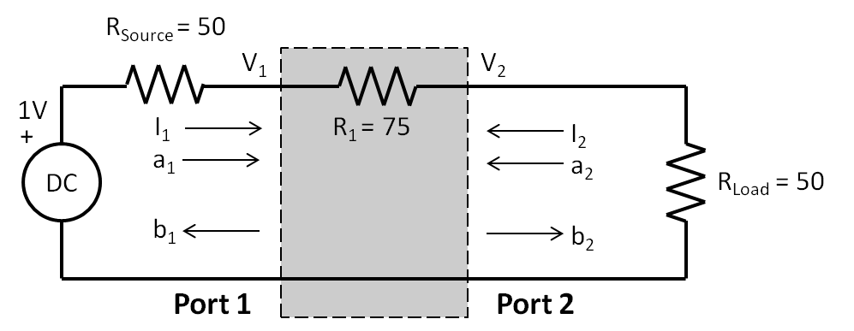

Figure 1.11 showing the forward schematic diagram of a series 2-port resistor

Here are the steps we will take to determine s11 and s21 and the source is at port 1 and the load is at port 2:

Step 1: Set the source voltage to 1 volt, this makes the math easier and does not change the s-parameters.

Step 2: Use Kirchhoff’s Voltage Law to find I1, I2, V1, and V2.

|  |  |  |
| --- | --- | --- |
|  |  | (1-44) |

|  |  |  |
| --- | --- | --- |
|  |  | (1-45) |

|  |  |  |
| --- | --- | --- |
|  |  | (1-46) |

|  |  |  |
| --- | --- | --- |
|  |  | (1-47) |

|  |  |  |
| --- | --- | --- |
|  |  | (1-48) |

|  |  |  |
| --- | --- | --- |
|  |  | (1-49) |

Step 3: Plug in the voltages and currents from step 3 into equations 1-33 and notice that you can cancel the denominators,

|  |  |  |
| --- | --- | --- |
|  | $$2\sqrt{50}$$ | (1-50) |

|  |  |  |
| --- | --- | --- |
|  |  | (1-51) |

Never forget to change the sign of I2 since Kirchhoff has current flowing out of port 2, but the s-parameters have their currents flowing into all their ports. So be careful. That is why there is the double minus sign in equation 1-52

|  |  |  |
| --- | --- | --- |
|  | $$s_{21}=\frac{b_{2}}{a_{1}}=\frac{\frac{50}{175}--\frac{1}{175}*50}{\frac{125}{175}+\frac{1}{175}*50}=0.571$$ | (1-52) |

Now for s22 and s12 where the source is at port 2 and the load is at port 1, we follow the same steps for the s-parameters as above, but from the reverse direction. This is shown in figure 1.12. Note again, it is very important to note that all currents flows into the port, not out of the port. Thus in figure 1.12, I1 flows into port 1 and I2 flows into port 2.

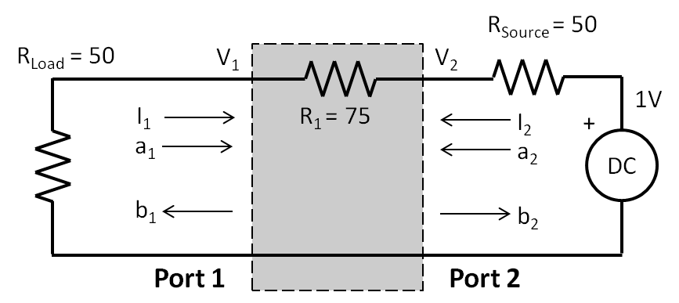

Figure 1.12 showing the reverse schematic diagram of a series 2-port resistor

Here are the steps we will take to determine s22 and s12:

Step 1: Set the source voltage to 1 volt

Step 2: Use Kirchhoff’s Voltage Law to find I1, I2, V1, and V2.

|  |  |  |
| --- | --- | --- |
|  |  | (1-53) |

|  |  |  |
| --- | --- | --- |
|  |  | (1-54) |

|  |  |  |
| --- | --- | --- |
|  |  | (1-55) |

|  |  |  |
| --- | --- | --- |
|  |  | (1-56) |

|  |  |  |
| --- | --- | --- |
|  |  | (1-57) |

|  |  |  |
| --- | --- | --- |
|  |  | (1-58) |

Step 3: Plug in the voltages and currents from step 3 into equations 1-33.

|  |  |  |
| --- | --- | --- |
|  | $$s_{22}=\frac{b_{2}}{a_{2}}=\frac{\frac{125}{175}-\frac{1}{175}*50}{\frac{125}{175}+\frac{1}{175}*50}=0.428$$ | (1-59) |

|  |  |  |
| --- | --- | --- |
|  |  | (1-60) |

As you might have noticed, s11 equals s22 and s21 equals s12. We call this a reciprocal network since we can flip the input and output and still obtain the same s-parameters. There are quite a few reciprocal networks out there and we can reduce the number of math steps when this happens.

So finally, let's put s-parameters in matrix form of **b = s * a** and the result is shown in equation 1-23. Power wave, **a** is the independent variable, and **b** is the dependent variable.

|  |  |  |
| --- | --- | --- |
|  | $$\left\lceil \begin{matrix}b_{1} \\ b_{2}\end{matrix}\right\rceil =\left[\begin{matrix}s_{11} & s_{12} \\ s_{21} & s_{22}\end{matrix}\right]*\left[\begin{matrix}a_{1} \\ a_{2}\end{matrix}\right]$$ | (1-61) |

Where **s** is,

|  |  |  |
| --- | --- | --- |
|  | $$s=\left[\begin{matrix}s_{11} & s_{12} \\ s_{21} & s_{22}\end{matrix}\right]=\left[\begin{matrix}0.428 & 0.571 \\ 0.571 & 0.428\end{matrix}\right]$$ | (1-61) |

So these are s-parameters of a series 75 Ohm resistor referenced to a 50 Ohm system where the source and load resistances are 50 Ohms.

The s-parameters of a Parallel Resistor

So let’s apply equations 1-51 and 1-52 to a network having a resistor in parallel as shown in figure 1.13. Note that in this case, V1 = V2. Note also, the direction of I2 as it is defined as flowing into port 2, not coming out of the port 2, so it will have negative value.

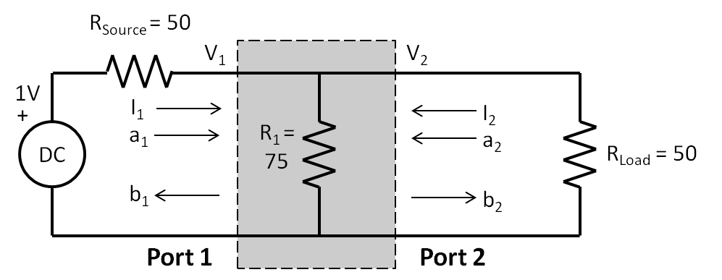

Figure 1-13 The s-parameters of a 75 Ohm resistor in parallel

So all we have to do is find I1, I2, V1, and V and plug them into equations 1-51 and 1-52 and not forgetting to note the direction and sign of the current I2, we have the following,

|  |  |  |
| --- | --- | --- |
|  | $$I_{1}=\frac{1}{50+\frac{1}{\frac{1}{75}+\frac{1}{50}}}=0.0125A$$ | (1-62) |

|  |  |  |
| --- | --- | --- |
|  |  | (1-63) |

|  |  |  |
| --- | --- | --- |
|  |  | (1-64) |

|  |  |  |
| --- | --- | --- |
|  |  | (1-65) |

|  |  |  |
| --- | --- | --- |
|  |  | (1-66) |

|  |  |  |
| --- | --- | --- |
|  |  | (1-67) |

Since this is a reciprocal component, s22 = s11 and s12 = s21.

|  |  |  |
| --- | --- | --- |
|  |  | (1-68) |

Notice that s11 is negative in the parallel resistor case and positive in the series resistor case. What I have not told you so far is that s-parameters are **complex numbers** that have a **x** real part and a **y** imaginary part. s11 from equation 1-68. So we need to express s11 as a complex number. Here is what that looks like,

|  |  |  |
| --- | --- | --- |
|  | $$s_{11}=-0.25+j*0; j=\sqrt{-1}; j^{2}=-1$$ | (1-69) |

Such that,

|  |  |  |
| --- | --- | --- |
|  | $$s_{11}Magnitude= \sqrt{{-0.25}^{2}+0^{2}}=0.25 \\ s_{11}Angle=\tan^{-1}\left(\frac{0}{-0.25}\right)=180°$$ | (1-70) |

So let’s repeat equation 1-68 and add the phase information to get,

|  |  |  |
| --- | --- | --- |
|  | $$s=\left[\begin{matrix}s_{11} & s_{12} \\ s_{21} & s_{22}\end{matrix}\right]=\left[\begin{matrix}0.25∠180 & 0.75∠0 \\ 0.75∠0 & 0.250.25∠180\end{matrix}\right]$$ | (1-71) |

We can redo all the analysis for these 75 Ohm resistors by using **nPort** as shown in listing 1.4. We introduce the nPort resistor methods, nP.seR() and nP.paR() for series and parallel resistors respectively. We also introduce the nPort output method, nP.out().

Listing 1.4 The s-parameters a series and parallel 75 Ohm Resistor

// define the frequency

g = nP.global;

g.fList = [0]; // this is DC

// 75 Ohm resistor in series

var R1 = nP.seR(75);

var R1Out = R1.out('s11mag','s11ang','s21mag','s21ang');

console.log('75 Ohm resistor in series ...');

console.log(R1Out[0]); // Table data name

console.log(R1Out[1]); // Table data

// 75 Ohm resistor in parallel

var R2 = nP.paR(75);

var R2Out = R2.out('s11mag','s11ang','s21mag','s21ang');

console.log('75 Ohm resistor in parallel ...');

console.log(R2Out[0]); // Table data name

console.log(R2Out[1]); // Table data

**The 3dB Attenuator solution #5 of 5:**

**Using nPort s-parameter methods.**

Now for our last analysis of the 3 dB attenuator at DC. We will now use **nPort** to do everything. First, let us redraw the attenuator network of figure 1-10 as a cascade of three resistor 2-ports as shown in figure 1-14 below. So we will define three resistor 2-ports in **nPort**, then we will cascade them together into a new 2-port that represents all three resistors.

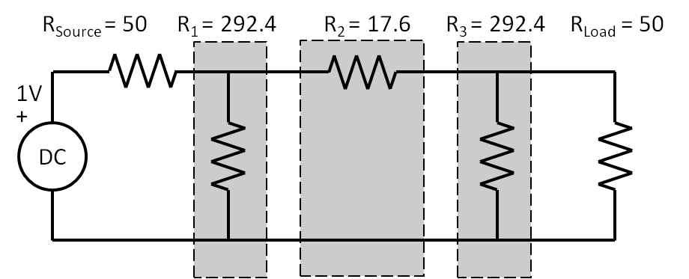

Figure 1-14 Showing three 2-port resistor networks in cascade

So far we have calculated the attenuation of -2.9987 dB by four different methods. Now are about to solve it using nPort as shown in listing 1.5 below. We introduce the nP.cascade() method to create an overall 2-port that is the cascade of the three resistor 2-ports.

Listing 1.5 shows the full up nPort methodology using the functions: paR(R), seR(R), and cascade(nPort1,nPort2, … , nPortN).

// define the frequency

g = nP.global;

g.fList = [0];

// define the resistors

var R1 = nP.paR(292.4);

var R2 = nP.seR(17.6);

var R3 = nP.paR(292.4);

// cascade them all together

var attn = nP.cascade(R1,R2,R3);

var attnOut = attn.out('s21dB');

// output the result to the console

console.log('The 3 dB attenuator ...');

console.log(attnOut[0]); // Table data name

console.log(attnOut[1]); // Table data

Note how few lines of code are required to give the expected result of -3 dB.

In the next chapter, we will continue on by examining the characteristics of Inductors and Capacitors driven by an AC source.

**The s-parameters of the 1-ports open, short, and load**

These 1-ports are used for terminations mainly. Since they are 1-ports, there is only one s-parameter, s11. So we will determine s11 for each of these three 1-ports.

Figure 1-15 shows the schematic of the open 1-port.

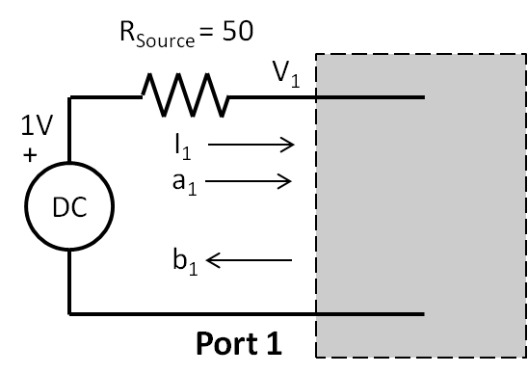

Figure 1-15 showing the 1-port open.

To determine s11, we must use V1 and I1 to determine a1 and b1. By inspection, I1 is 0A, and V1 is 1V. Using equation 1-66, we plug in values for V1 and I1. Notice, that even though we select V equal to 1, it could have been any value, s11 would not change.

|  |  |  |
| --- | --- | --- |
|  | $$s_{11}=\frac{b_{1}}{a_{1}}=\frac{1-0*50}{1+0*50}=1∠0; open$$ | (1-72) |

Since the magnitude of s11 is 1, this means that all of the power is reflected back to the source.

Figure 1-16 shows the schematic of the 1-port. short

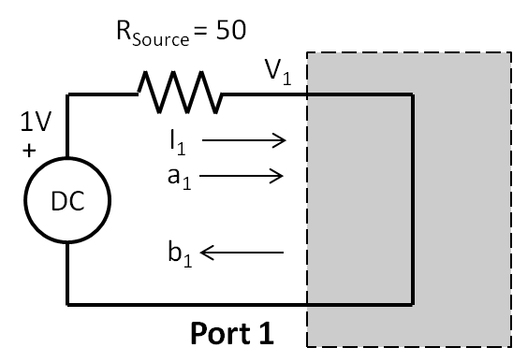

Figure 1-16 showing the 1-port short.

As with the 1-port short, we can determine V1 and I1 by inspection, then apply equation 1-66 to find s11. So in this case, V1 is equal to 0V and I1 is equal to 1/50A. Notice again, it does not matter what value of V to apply, s11 does not change.

|  |  |  |
| --- | --- | --- |
|  | $$s_{11}=\frac{b_{1}}{a_{1}}=\frac{0-\frac{1}{50}*50}{0+\frac{1}{50}*50}=-1=1∠180; short$$ | (1-73) |

Since the magnitude of s11 is 1, this means that all of the power is reflected back to the source.

The last 1-port we consider is the 1-port load shown in figure 1-17.

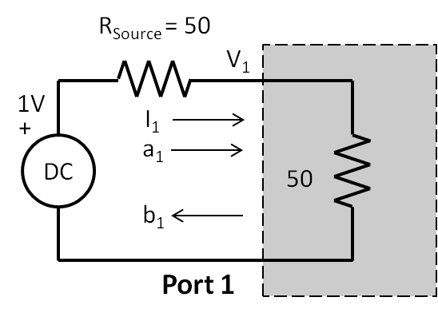

Figure 1-17 showing the 1-port load.

So by inspection, V1 = 0.5V and I1 = 1/100A.

|  |  |  |
| --- | --- | --- |
|  | $$s_{11}=\frac{b_{1}}{a_{1}}=\frac{0.5-\frac{1}{100}*50}{0.5+\frac{1}{100}*50}=0∠0; load$$ | (1-74) |

Since the magnitude of s11 is o, this means that all of the power is absorbed or dissipated by the load. Since the source resistor and the load resistor are same, there is maximum power transfer from the source.

**The s-parameters of a 2-port through**

Figure 1-18 shows the schematic of a 2-port through. V1 equals V2 equals 0.5V. I1 equals I2 equals 1/100A

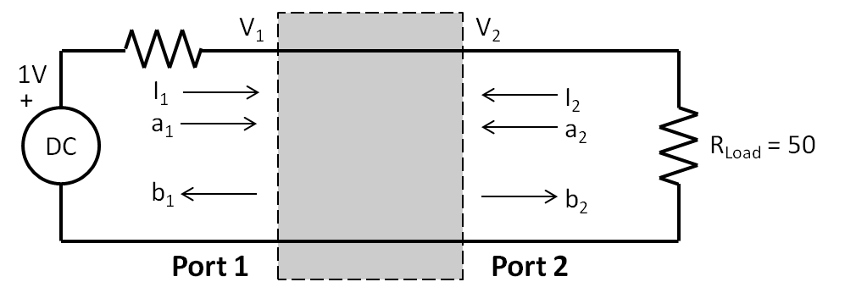

So we determine s11,

|  |  |  |
| --- | --- | --- |
|  | $$s_{11}=\frac{b_{1}}{a_{1}}=\frac{0.5-\frac{1}{100}*50}{0.5+\frac{1}{100}*50}=0∠0; load$$ | (1-75) |

Likewise, we determine, s21

|  |  |  |
| --- | --- | --- |
|  | $$s_{21}=\frac{b_{2}}{a_{1}}=\frac{0.5--\frac{1}{100}*50}{0.5+\frac{1}{100}*50}=1∠0; through$$ | (1-76) |

So here is the s-parameter matrix for the through. Since s21 and s12 are 1, all of the power is transferred to the load with no reflection.1

|  |  |  |
| --- | --- | --- |
|  | $$s=\left[\begin{matrix}s_{11} & s_{12} \\ s_{21} & s_{22}\end{matrix}\right]=\left[\begin{matrix}1∠0 & 0∠0 \\ 0∠0 & 1∠0\end{matrix}\right]$$ | (1-77) |

Our last 2-port will be an ideal voltage amplifier and it is shown in figure 1-19.

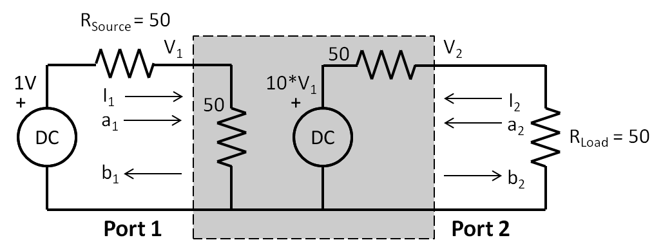

Figure 1-19 showing the schematic of an ideal voltage amplifier

Since this is 2-port, we expect to list 4 s-parameters, s11, s21, s12, and s22. By inspection of port 1, we see a 1-port load, therefore s11 = 0. By inspection from port 2, and if we placed the source at port 2 and the load at port 1, again we see 1-port load, so s22 = 0, note too that V1 and I1 are equal to 0V and 0A respectively, therefore, s12 is 0. So here is our s-parameter matrix so far,

|  |  |  |
| --- | --- | --- |
|  | $$s=\left[\begin{matrix}s_{11} & s_{12} \\ s_{21} & s_{22}\end{matrix}\right]=\left[\begin{matrix}0∠0 & 0∠0 \\ ?∠0 & 0∠0\end{matrix}\right]$$ | (1-78) |

We need only determine s21. So let’s do that. V1 is equal to 0.5V, I1 is equal to 1/100A. Now we need to find V2 and I1. We introduce the dependant voltage controlled voltage source having a gain, g of 10. Therefore if V1 is 0.5V, the dependant voltage source output voltage is 5V, then V2 is 2.5V and I2 is 5/100V. Right?

|  |  |  |
| --- | --- | --- |
|  | $$s_{21}=\frac{b_{2}}{a_{1}}=\frac{5--\frac{5}{100}*50}{0.5+\frac{1}{100}*50}=7.5∠0; amplifier$$ | (1-79) |

So here is the complete s-parameter matrix.

|  |  |  |
| --- | --- | --- |
|  | $$s=\left[\begin{matrix}s_{11} & s_{12} \\ s_{21} & s_{22}\end{matrix}\right]=\left[\begin{matrix}0∠0 & 0∠0 \\ 7.5∠0 & 0∠0\end{matrix}\right]$$ | (1-80) |

Turns out you can derive a generalized expression for s21 as,

|  |  |  |
| --- | --- | --- |
|  | $$s_{21}=7.5*g$$ | (1-81) |

So we have covered quite a bit a ground here in this chapter. We can get a lot of insight into the electrical performance of AC networks that can be analyzed at DC with simpler arithmetic. We introduced JavaScript and nPort that mechanizes the analysis with a minimum of code.

In the next chapter, we will continue on by examining the characteristics of Inductors and Capacitors driven by an AC source.

**Problems**

1. Use the voltage divider technique to solve the 10dB attenuator network by repeating the analysis, by hand, of figure 1-8 but with values of R1 = R3 = 96.25 Ohms and R2 = 71.15 Ohms.

2. For practicing with Matrices and **nPort**, modify and run the listing 1.3 with the schematic shown in figure 1-p2 below to display I5 in the console. Answer is 0.02565 Amps. Hint: Here is part of the resistor matrix shown in equation 1-p2, pay attention to the pattern to fill out the matrix **by inspection** of the schematic. (This problem is example 3-4.1 on page 90 of “Basic Circuit Theory with Digital Computations” by Lawrence P. Huelsman, 1972.)

|  |  |  |
| --- | --- | --- |
|  | $V=\left[\begin{matrix}38.9 \\ 42.1 \\ 59.76 \\ 0 \\ 0\end{matrix}\right];I=\left[\begin{matrix}I_{1} \\ I_{2} \\ I_{3} \\ I_{4} \\ I_{5}\end{matrix}\right]$; R = … |  |

|  |  |  |
| --- | --- | --- |
|  |  |  |

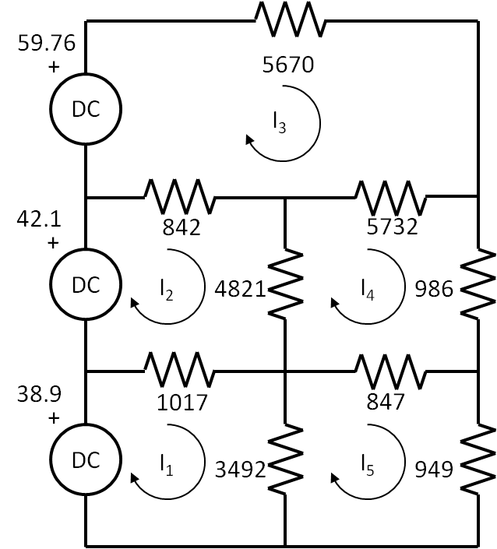

Figure 1-p2

2 AC and Resistors, Inductors, and Capacitors

In this chapter, we turn our attention to AC with resistors, Inductors, and Capacitors. First, we will compare AC with DC with respect to power. Once we do that, everything we did in chapter 1 with DC we could repeat with AC. Second, we will introduce complex numbers and analysis. Third, we can design and analyze a wide variety of circuits such as LC filters. There are several **nPort** methods to quickly design and analyze filters. We will use the **nPort** charting method nP.lineChart() to plot the frequency responses on a web page. Fourth, we will introduce the ideal transformer nPort method and simulate the frequency response of crystal filters. So far, we have been considering 2-port networks and cascading them into a final 2-port. If there are only 2-ports available, there are many circuits that cannot be analyzed with 2-ports alone. Now, fifth, we will introduce the **nPort** nodal analysis method, nP.nodal() and introduce interconnect 3-ports. We will now have quite a large set of tools to analyze a wide variety of RF circuits with lumped components. A component is considered lumped if it’s largest dimension is less than say, one tenth of a wavelength at the highest frequency of operation. We will finish the chapter by analyzing transmission lines using lumped elements. In chapter 3, we introduce distributive components that are used for microwave and millimeter wave frequencies.

**AC and DC Power**

Here is an important question. As shown in figure 2-1, suppose there are two circuits with the same resistors that are at 200 °F, the first resistor is connected to a DC source and the second resistor is connected to an AC source. The question is, what is the equivalent “AC power” with respect the DC power? We could imagine two electric water boilers. The heating element in each boiler is the same, the resistors are the same, their temperatures are the same at 200 °F. The only difference is that one boiler is operating at DC and the other one is operating at AC. It is important to have this concept of Watts dissipated at DC equaling Watts dissipated at AC **because** they are at the same temperature. As you can probably tell already, 120 VoltsRMS at AC is equivalent to 120 Volts at DC.

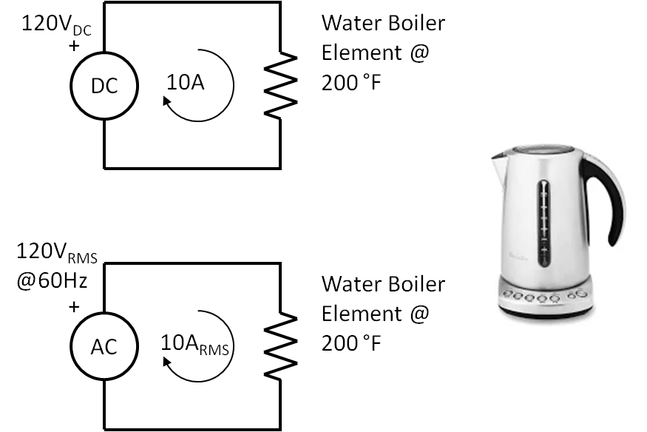

Figure 2-1 Shows equivalence of DC and AC power in Watts

This chapter is about AC and RLC networks, but the idea is to transmit the desired power through the network efficiently. So, it is always about power, and power is in Watts. If you take the average of a sinewave over one period, the answer is zero V. We need to **an equivelent voltage.** over a period of an AC cycle. The period of an AC power outlet in your kitchen defined as T, as in

|  |  |  |
| --- | --- | --- |
|  | $$T=\frac{1}{f}=\frac{1}{60}=0.0167S$$ | (2-1) |

Where T, in seconds, is the duration of the period, and f, in Hz, is the frequency. Suppose we divide up the period into 100 points, so we will have 100 voltages that follow the cosine curve. Here is what the voltage points are,

|  |  |  |
| --- | --- | --- |
|  | $$V_{n}=V_{peak}*\cos\left(2*π*f*\frac{1}{f}*\frac{n}{100}\right); \\ =V_{peak}*\cos\left(2*π*\frac{n}{100}\right) \\ for n=0 →100$$ | (2-2) |

Where f is the frequency, in Hz and t, in seconds is (1/f)*(n/100) factor are times. Picture Vn in equation 2-2 as 101 points along a cosine curve. The voltage will begin at a positive maximum voltage at point 0, then go negative after 25 points, will go to a negative maximum at 50 points, and go positive at 75 points, and be at a maximum again at 100 points. The average voltage is,

|  |  |  |
| --- | --- | --- |
|  | $$V_{average}=\frac{V_{n=0}+V_{1}+ …+ V_{99}}{100}=0V$$ | (2-3) |

The average is 0 since there are just as many negative values as positive values, so the numerator in equation 2-2 will be 0. But there AC power since the resistor is at temperature. What is a path forward? Take each of the voltages and square them, then add them all up and find divide by 100 to find the mean, and then take the square root of the mean to determine the equivalent DC voltage. So we “square” it, “mean” it, and “root” it. Saying the steps backwards … root, mean, square … RMS. Here is what this looks like in a formula,

|  |  |  |
| --- | --- | --- |
|  | $$V_{rms}=\sqrt{\frac{{V_{0}}^{2}{{+V}_{1}}^{2}+…+{V_{99}}^{2}}{100}}$$ | (2-4) |

So plugging equation 2-2 into equation 2-4 we have

|  |  |  |
| --- | --- | --- |
|  | $$V_{rms}=\sqrt{\frac{V_{peak}\cos{{\left(2π\frac{0}{100}\right)}^{2}+…+V_{peak}\cos{{\left(2π\frac{99}{100}\right)}^{2}}}}{100}}$$ | (2-5) |

If you started out with Vpeak at 170V, and solved equation 2-5, you would find that Vrms is 120V. Listing 2.1 below shows a JavaScript routine that evaluates equation 2-4 to obtain Vrms equal to 120.208V.

Listing 2.1 shows a JavaScript based solution of equation 2-5

// rms calculation - root, mean, square

var vPeak = 170, v = 0, vRMS = 0;

var pi = Math.PI;

var n = 0, N = 100;

for (n; n<N; n++) {

v = v + (vPeak*Math.cos(2*pi*(n/N)))**2;

}

vRMS = Math.sqrt(v/N);

console.log('Vrms is ' + vRMS);

In listing 2.1, lower Vpeak from 170V down to 1V. Vrms should be 0.707V. Look familiar?

|  |  |  |
| --- | --- | --- |
|  | $$V_{rms}= \frac{1}{\sqrt{2}}*V_{peak}$$ | (2-6) |

This is only true for cosine waves and not true for periodic waves such triangle waves and square waves. So to begin analysis in AC, we use RMS values for voltages and currents, then we can calculate power by simply multiplying them together. Also, there is no such thing as an RMS resistance.

Cosine waves are used since Vpeak is at the beginning of the period, if we used sine wave, Vpeak is a quarter way into the period, right?

**Complex Numbers**

In chapter 1, we defined the power waves, **a** and **b** with equation 1-38 and we just treated them as simple DC equations.

|  |  |  |
| --- | --- | --- |
|  | $$a_{1}=\frac{V_{1}+I_{1}*50}{2\sqrt{50}}; b_{1}=\frac{V_{1}-I_{1}*50}{2\sqrt{50}}; \\ a_{2}=\frac{V_{2}+I_{2}*50}{2\sqrt{50}}; b_{2}=\frac{V_{2}-I_{2}*50}{2\sqrt{50}}$$ | (1-38) |

However, power waves, and s-parameters are expressed as complex numbers, which means they have a real part, x; and an imaginary part, y. This means that equation 1-38 must be treated as complex number equation. To solve equation 1-38 we have to express everything in complex form and use complex add, subtract, multiply and divide operators.

We will repeat finding the s-parameters of a 75 Ohm resistor in parallel as described in chapter 1, but with complex numbers.

|  |  |  |
| --- | --- | --- |
|  | $$I_{1}=0.0125A$$ | (1-62) |

|  |  |  |
| --- | --- | --- |
|  |  | (1-63) |

|  |  |  |
| --- | --- | --- |
|  |  | (1-64) |

|  |  |  |
| --- | --- | --- |
|  |  | (1-65) |

|  |  |  |
| --- | --- | --- |
|  |  | (1-66) |

|  |  |  |
| --- | --- | --- |
|  |  | (1-67) |

.

3 CHAPTER NAME

Insert chapter three text here. Insert chapter three text here. Insert chapter three text here. Insert chapter three text here. Insert chapter three text here. Insert chapter three text here. Insert chapter three text here. Insert chapter three text here. Insert chapter three text here. Insert chapter three text here. Insert chapter three text here. Insert chapter three text here.

Insert chapter three text here. Insert chapter three text here. Insert chapter three text here. Insert chapter three text here. Insert chapter three text here. Insert chapter three text here. Insert chapter three text here. Insert chapter three text here. Insert chapter three text here. Insert chapter three text here. Insert chapter three text here. Insert chapter three text here.

Insert chapter three text here. Insert chapter three text here. Insert chapter three text here. Insert chapter three text here. Insert chapter three text here. Insert chapter three text here. Insert chapter three text here. Insert chapter three text here. Insert chapter three text here. Insert chapter three text here. Insert chapter three text here. Insert chapter three text here. Insert chapter three text here. Insert chapter three text here. Insert chapter three text here. Insert chapter three text here. Insert chapter three text here. Insert chapter three text here. Insert chapter three text here. Insert chapter three text here. Insert chapter three text here. Insert chapter three text here. Insert chapter three text here. Insert chapter three text here. Insert chapter three text here. Insert chapter three text here. Insert chapter three text here. Insert chapter three text here. Insert chapter three text here. Insert chapter three text here. Insert chapter three text here. Insert chapter three text here. Insert chapter three text here. Insert chapter three text here. Insert chapter three text here. Insert chapter three text here.

Insert chapter three text here. Insert chapter three text here. Insert chapter three text here. Insert chapter three text here. Insert chapter three text here. Insert chapter three text here. Insert chapter three text here. Insert chapter three text here. Insert chapter three text here. Insert chapter three text here. Insert chapter three text here. Insert chapter three text here. Insert chapter three text here. Insert chapter three text here. Insert chapter three text here. Insert chapter three text here. Insert chapter three text here. Insert chapter three text here. Insert chapter three text here. Insert chapter three text here. Insert chapter three text here. Insert chapter three text here. Insert chapter three text here. Insert chapter three text here. Insert chapter three text here. Insert chapter three text here. Insert chapter three text here. Insert chapter three text here. Insert chapter three text here. Insert chapter three text here. Insert chapter three text here. Insert chapter three text here. Insert chapter three text here. Insert chapter three text here. Insert chapter three text here. Insert chapter three text here.

Insert chapter three text here. Insert chapter three text here. Insert chapter three text here. Insert chapter three text here. Insert chapter three text here. Insert chapter three text here. Insert chapter three text here. Insert chapter three text here. Insert chapter three text here. Insert chapter three text here. Insert chapter three text here. Insert chapter three text here. Insert chapter three text here. Insert chapter three text here. Insert chapter three text here. Insert chapter three text here. Insert chapter three text here. Insert chapter three text here. Insert chapter three text here. Insert chapter three text here. Insert chapter three text here. Insert chapter three text here. Insert chapter three text here. Insert chapter three text here. Insert chapter three text here. Insert chapter three text here. Insert chapter three text here. Insert chapter three text here. Insert chapter three text here. Insert chapter three text here. Insert chapter three text here. Insert chapter three text here. Insert chapter three text here. Insert chapter three text here. Insert chapter three text here. Insert chapter three text here.

Insert chapter three text here. Insert chapter three text here. Insert chapter three text here. Insert chapter three text here. Insert chapter three text here. Insert chapter three text here. Insert chapter three text here. Insert chapter three text here. Insert chapter three text here. Insert chapter three text here. Insert chapter three text here. Insert chapter three text here. Insert chapter three text here. Insert chapter three text here. Insert chapter three text here. Insert chapter three text here. Insert chapter three text here. Insert chapter three text here. Insert chapter three text here. Insert chapter three text here. Insert chapter three text here. Insert chapter three text here. Insert chapter three text here. Insert chapter three text here. Insert chapter three text here. Insert chapter three text here. Insert chapter three text here. Insert chapter three text here. Insert chapter three text here. Insert chapter three text here. Insert chapter three text here. Insert chapter three text here. Insert chapter three text here. Insert chapter three text here. Insert chapter three text here. Insert chapter three text here.

Insert chapter three text here. Insert chapter three text here. Insert chapter three text here. Insert chapter three text here. Insert chapter three text here. Insert chapter three text here. Insert chapter three text here. Insert chapter three text here. Insert chapter three text here. Insert chapter three text here. Insert chapter three text here. Insert chapter three text here. Insert chapter three text here. Insert chapter three text here. Insert chapter three text here. Insert chapter three text here. Insert chapter three text here. Insert chapter three text here. Insert chapter three text here. Insert chapter three text here. Insert chapter three text here. Insert chapter three text here. Insert chapter three text here. Insert chapter three text here. Insert chapter three text here. Insert chapter three text here. Insert chapter three text here. Insert chapter three text here. Insert chapter three text here. Insert chapter three text here. Insert chapter three text here. Insert chapter three text here. Insert chapter three text here. Insert chapter three text here. Insert chapter three text here. Insert chapter three text here.

4 CHAPTER NAME

Insert chapter four text here. Insert chapter four text here. Insert chapter four text here. Insert chapter four text here. Insert chapter four text here. Insert chapter four text here. Insert chapter four text here. Insert chapter four text here. Insert chapter four text here. Insert chapter four text here. Insert chapter four text here. Insert chapter four text here.

Insert chapter four text here. Insert chapter four text here. Insert chapter four text here. Insert chapter four text here. Insert chapter four text here. Insert chapter four text here. Insert chapter four text here. Insert chapter four text here. Insert chapter four text here. Insert chapter four text here. Insert chapter four text here. Insert chapter four text here.

Insert chapter four text here. Insert chapter four text here. Insert chapter four text here. Insert chapter four text here. Insert chapter four text here. Insert chapter four text here. Insert chapter four text here. Insert chapter four text here. Insert chapter four text here. Insert chapter four text here. Insert chapter four text here. Insert chapter four text here. Insert chapter four text here. Insert chapter four text here. Insert chapter four text here. Insert chapter four text here. Insert chapter four text here. Insert chapter four text here. Insert chapter four text here. Insert chapter four text here. Insert chapter four text here. Insert chapter four text here. Insert chapter four text here. Insert chapter four text here. Insert chapter four text here. Insert chapter four text here. Insert chapter four text here. Insert chapter four text here. Insert chapter four text here. Insert chapter four text here. Insert chapter four text here. Insert chapter four text here. Insert chapter four text here. Insert chapter four text here. Insert chapter four text here. Insert chapter four text here.

Insert chapter four text here. Insert chapter four text here. Insert chapter four text here. Insert chapter four text here. Insert chapter four text here. Insert chapter four text here. Insert chapter four text here. Insert chapter four text here. Insert chapter four text here. Insert chapter four text here. Insert chapter four text here. Insert chapter four text here. Insert chapter four text here. Insert chapter four text here. Insert chapter four text here. Insert chapter four text here. Insert chapter four text here. Insert chapter four text here. Insert chapter four text here. Insert chapter four text here. Insert chapter four text here. Insert chapter four text here. Insert chapter four text here. Insert chapter four text here. Insert chapter four text here. Insert chapter four text here. Insert chapter four text here. Insert chapter four text here. Insert chapter four text here. Insert chapter four text here. Insert chapter four text here. Insert chapter four text here. Insert chapter four text here. Insert chapter four text here. Insert chapter four text here. Insert chapter four text here.

Insert chapter four text here. Insert chapter four text here. Insert chapter four text here. Insert chapter four text here. Insert chapter four text here. Insert chapter four text here. Insert chapter four text here. Insert chapter four text here. Insert chapter four text here. Insert chapter four text here. Insert chapter four text here. Insert chapter four text here. Insert chapter four text here. Insert chapter four text here. Insert chapter four text here. Insert chapter four text here. Insert chapter four text here. Insert chapter four text here. Insert chapter four text here. Insert chapter four text here. Insert chapter four text here. Insert chapter four text here. Insert chapter four text here. Insert chapter four text here. Insert chapter four text here. Insert chapter four text here. Insert chapter four text here. Insert chapter four text here. Insert chapter four text here. Insert chapter four text here. Insert chapter four text here. Insert chapter four text here. Insert chapter four text here. Insert chapter four text here. Insert chapter four text here. Insert chapter four text here.

Insert chapter four text here. Insert chapter four text here. Insert chapter four text here. Insert chapter four text here. Insert chapter four text here. Insert chapter four text here. Insert chapter four text here. Insert chapter four text here. Insert chapter four text here. Insert chapter four text here. Insert chapter four text here. Insert chapter four text here. Insert chapter four text here. Insert chapter four text here. Insert chapter four text here. Insert chapter four text here. Insert chapter four text here. Insert chapter four text here. Insert chapter four text here. Insert chapter four text here. Insert chapter four text here. Insert chapter four text here. Insert chapter four text here. Insert chapter four text here. Insert chapter four text here. Insert chapter four text here. Insert chapter four text here. Insert chapter four text here. Insert chapter four text here. Insert chapter four text here. Insert chapter four text here. Insert chapter four text here. Insert chapter four text here. Insert chapter four text here. Insert chapter four text here. Insert chapter four text here.

Insert chapter four text here. Insert chapter four text here. Insert chapter four text here. Insert chapter four text here. Insert chapter four text here. Insert chapter four text here. Insert chapter four text here. Insert chapter four text here. Insert chapter four text here. Insert chapter four text here. Insert chapter four text here. Insert chapter four text here. Insert chapter four text here. Insert chapter four text here. Insert chapter four text here. Insert chapter four text here. Insert chapter four text here. Insert chapter four text here. Insert chapter four text here. Insert chapter four text here. Insert chapter four text here. Insert chapter four text here. Insert chapter four text here. Insert chapter four text here. Insert chapter four text here. Insert chapter four text here. Insert chapter four text here. Insert chapter four text here. Insert chapter four text here. Insert chapter four text here. Insert chapter four text here. Insert chapter four text here. Insert chapter four text here. Insert chapter four text here. Insert chapter four text here. Insert chapter four text here.

Insert chapter four text here. Insert chapter four text here. Insert chapter four text here. Insert chapter four text here. Insert chapter four text here. Insert chapter four text here. Insert chapter four text here. Insert chapter four text here. Insert chapter four text here. Insert chapter four text here. Insert chapter four text here. Insert chapter four text here. Insert chapter four text here. Insert chapter four text here. Insert chapter four text here. Insert chapter four text here. Insert chapter four text here. Insert chapter four text here. Insert chapter four text here. Insert chapter four text here. Insert chapter four text here. Insert chapter four text here. Insert chapter four text here. Insert chapter four text here. Insert chapter four text here. Insert chapter four text here. Insert chapter four text here. Insert chapter four text here. Insert chapter four text here. Insert chapter four text here. Insert chapter four text here. Insert chapter four text here. Insert chapter four text here. Insert chapter four text here. Insert chapter four text here. Insert chapter four text here.

5 CHAPTER NAME

Insert chapter five text here. Insert chapter five text here. Insert chapter five text here. Insert chapter five text here. Insert chapter five text here. Insert chapter five text here. Insert chapter five text here. Insert chapter five text here. Insert chapter five text here. Insert chapter five text here. Insert chapter five text here. Insert chapter five text here.

Insert chapter five text here. Insert chapter five text here. Insert chapter five text here. Insert chapter five text here. Insert chapter five text here. Insert chapter five text here. Insert chapter five text here. Insert chapter five text here. Insert chapter five text here. Insert chapter five text here. Insert chapter five text here. Insert chapter five text here.

Insert chapter five text here. Insert chapter five text here. Insert chapter five text here. Insert chapter five text here. Insert chapter five text here. Insert chapter five text here. Insert chapter five text here. Insert chapter five text here. Insert chapter five text here. Insert chapter five text here. Insert chapter five text here. Insert chapter five text here. Insert chapter five text here. Insert chapter five text here. Insert chapter five text here. Insert chapter five text here. Insert chapter five text here. Insert chapter five text here. Insert chapter five text here. Insert chapter five text here. Insert chapter five text here. Insert chapter five text here. Insert chapter five text here. Insert chapter five text here. Insert chapter five text here. Insert chapter five text here. Insert chapter five text here. Insert chapter five text here. Insert chapter five text here. Insert chapter five text here. Insert chapter five text here. Insert chapter five text here. Insert chapter five text here. Insert chapter five text here. Insert chapter five text here. Insert chapter five text here.

Insert chapter five text here. Insert chapter five text here. Insert chapter five text here. Insert chapter five text here. Insert chapter five text here. Insert chapter five text here. Insert chapter five text here. Insert chapter five text here. Insert chapter five text here. Insert chapter five text here. Insert chapter five text here. Insert chapter five text here. Insert chapter five text here. Insert chapter five text here. Insert chapter five text here. Insert chapter five text here. Insert chapter five text here. Insert chapter five text here. Insert chapter five text here. Insert chapter five text here. Insert chapter five text here. Insert chapter five text here. Insert chapter five text here. Insert chapter five text here. Insert chapter five text here. Insert chapter five text here. Insert chapter five text here. Insert chapter five text here. Insert chapter five text here. Insert chapter five text here. Insert chapter five text here. Insert chapter five text here. Insert chapter five text here. Insert chapter five text here. Insert chapter five text here. Insert chapter five text here.

Insert chapter five text here. Insert chapter five text here. Insert chapter five text here. Insert chapter five text here. Insert chapter five text here. Insert chapter five text here. Insert chapter five text here. Insert chapter five text here. Insert chapter five text here. Insert chapter five text here. Insert chapter five text here. Insert chapter five text here. Insert chapter five text here. Insert chapter five text here. Insert chapter five text here. Insert chapter five text here. Insert chapter five text here. Insert chapter five text here. Insert chapter five text here. Insert chapter five text here. Insert chapter five text here. Insert chapter five text here. Insert chapter five text here. Insert chapter five text here. Insert chapter five text here. Insert chapter five text here. Insert chapter five text here. Insert chapter five text here. Insert chapter five text here. Insert chapter five text here. Insert chapter five text here. Insert chapter five text here. Insert chapter five text here. Insert chapter five text here. Insert chapter five text here. Insert chapter five text here.

Insert chapter five text here. Insert chapter five text here. Insert chapter five text here. Insert chapter five text here. Insert chapter five text here. Insert chapter five text here. Insert chapter five text here. Insert chapter five text here. Insert chapter five text here. Insert chapter five text here. Insert chapter five text here. Insert chapter five text here. Insert chapter five text here. Insert chapter five text here. Insert chapter five text here. Insert chapter five text here. Insert chapter five text here. Insert chapter five text here. Insert chapter five text here. Insert chapter five text here. Insert chapter five text here. Insert chapter five text here. Insert chapter five text here. Insert chapter five text here. Insert chapter five text here. Insert chapter five text here. Insert chapter five text here. Insert chapter five text here. Insert chapter five text here. Insert chapter five text here. Insert chapter five text here. Insert chapter five text here. Insert chapter five text here. Insert chapter five text here. Insert chapter five text here. Insert chapter five text here.

Insert chapter five text here. Insert chapter five text here. Insert chapter five text here. Insert chapter five text here. Insert chapter five text here. Insert chapter five text here. Insert chapter five text here. Insert chapter five text here. Insert chapter five text here. Insert chapter five text here. Insert chapter five text here. Insert chapter five text here. Insert chapter five text here. Insert chapter five text here. Insert chapter five text here. Insert chapter five text here. Insert chapter five text here. Insert chapter five text here. Insert chapter five text here. Insert chapter five text here. Insert chapter five text here. Insert chapter five text here. Insert chapter five text here. Insert chapter five text here. Insert chapter five text here. Insert chapter five text here. Insert chapter five text here. Insert chapter five text here. Insert chapter five text here. Insert chapter five text here. Insert chapter five text here. Insert chapter five text here. Insert chapter five text here. Insert chapter five text here. Insert chapter five text here. Insert chapter five text here.

Insert chapter five text here. Insert chapter five text here. Insert chapter five text here. Insert chapter five text here. Insert chapter five text here. Insert chapter five text here. Insert chapter five text here. Insert chapter five text here. Insert chapter five text here. Insert chapter five text here. Insert chapter five text here. Insert chapter five text here. Insert chapter five text here. Insert chapter five text here. Insert chapter five text here. Insert chapter five text here. Insert chapter five text here. Insert chapter five text here. Insert chapter five text here. Insert chapter five text here. Insert chapter five text here. Insert chapter five text here. Insert chapter five text here. Insert chapter five text here. Insert chapter five text here. Insert chapter five text here. Insert chapter five text here. Insert chapter five text here. Insert chapter five text here. Insert chapter five text here. Insert chapter five text here. Insert chapter five text here. Insert chapter five text here. Insert chapter five text here. Insert chapter five text here. Insert chapter five text here.

6 CHAPTER NAME

Insert chapter six text here. Insert chapter six text here. Insert chapter six text here. Insert chapter six text here. Insert chapter six text here. Insert chapter six text here. Insert chapter six text here. Insert chapter six text here. Insert chapter six text here. Insert chapter six text here. Insert chapter six text here. Insert chapter six text here.

Insert chapter six text here. Insert chapter six text here. Insert chapter six text here. Insert chapter six text here. Insert chapter six text here. Insert chapter six text here. Insert chapter six text here. Insert chapter six text here. Insert chapter six text here. Insert chapter six text here. Insert chapter six text here. Insert chapter six text here.

Insert chapter six text here. Insert chapter six text here. Insert chapter six text here. Insert chapter six text here. Insert chapter six text here. Insert chapter six text here. Insert chapter six text here. Insert chapter six text here. Insert chapter six text here. Insert chapter six text here. Insert chapter six text here. Insert chapter six text here. Insert chapter six text here. Insert chapter six text here. Insert chapter six text here. Insert chapter six text here. Insert chapter six text here. Insert chapter six text here. Insert chapter six text here. Insert chapter six text here. Insert chapter six text here. Insert chapter six text here. Insert chapter six text here. Insert chapter six text here. Insert chapter six text here. Insert chapter six text here. Insert chapter six text here. Insert chapter six text here. Insert chapter six text here. Insert chapter six text here. Insert chapter six text here. Insert chapter six text here. Insert chapter six text here. Insert chapter six text here. Insert chapter six text here. Insert chapter six text here.

Insert chapter six text here. Insert chapter six text here. Insert chapter six text here. Insert chapter six text here. Insert chapter six text here. Insert chapter six text here. Insert chapter six text here. Insert chapter six text here. Insert chapter six text here. Insert chapter six text here. Insert chapter six text here. Insert chapter six text here. Insert chapter six text here. Insert chapter six text here. Insert chapter six text here. Insert chapter six text here. Insert chapter six text here. Insert chapter six text here. Insert chapter six text here. Insert chapter six text here. Insert chapter six text here. Insert chapter six text here. Insert chapter six text here. Insert chapter six text here. Insert chapter six text here. Insert chapter six text here. Insert chapter six text here. Insert chapter six text here. Insert chapter six text here. Insert chapter six text here. Insert chapter six text here. Insert chapter six text here. Insert chapter six text here. Insert chapter six text here. Insert chapter six text here. Insert chapter six text here.

Insert chapter six text here. Insert chapter six text here. Insert chapter six text here. Insert chapter six text here. Insert chapter six text here. Insert chapter six text here. Insert chapter six text here. Insert chapter six text here. Insert chapter six text here. Insert chapter six text here. Insert chapter six text here. Insert chapter six text here. Insert chapter six text here. Insert chapter six text here. Insert chapter six text here. Insert chapter six text here. Insert chapter six text here. Insert chapter six text here. Insert chapter six text here. Insert chapter six text here. Insert chapter six text here. Insert chapter six text here. Insert chapter six text here. Insert chapter six text here. Insert chapter six text here. Insert chapter six text here. Insert chapter six text here. Insert chapter six text here. Insert chapter six text here. Insert chapter six text here. Insert chapter six text here. Insert chapter six text here. Insert chapter six text here. Insert chapter six text here. Insert chapter six text here. Insert chapter six text here.

Insert chapter six text here. Insert chapter six text here. Insert chapter six text here. Insert chapter six text here. Insert chapter six text here. Insert chapter six text here. Insert chapter six text here. Insert chapter six text here. Insert chapter six text here. Insert chapter six text here. Insert chapter six text here. Insert chapter six text here. Insert chapter six text here. Insert chapter six text here. Insert chapter six text here. Insert chapter six text here. Insert chapter six text here. Insert chapter six text here. Insert chapter six text here. Insert chapter six text here. Insert chapter six text here. Insert chapter six text here. Insert chapter six text here. Insert chapter six text here. Insert chapter six text here. Insert chapter six text here. Insert chapter six text here. Insert chapter six text here. Insert chapter six text here. Insert chapter six text here. Insert chapter six text here. Insert chapter six text here. Insert chapter six text here. Insert chapter six text here. Insert chapter six text here. Insert chapter six text here.

Insert chapter six text here. Insert chapter six text here. Insert chapter six text here. Insert chapter six text here. Insert chapter six text here. Insert chapter six text here. Insert chapter six text here. Insert chapter six text here. Insert chapter six text here. Insert chapter six text here. Insert chapter six text here. Insert chapter six text here. Insert chapter six text here. Insert chapter six text here. Insert chapter six text here. Insert chapter six text here. Insert chapter six text here. Insert chapter six text here. Insert chapter six text here. Insert chapter six text here. Insert chapter six text here. Insert chapter six text here. Insert chapter six text here. Insert chapter six text here. Insert chapter six text here. Insert chapter six text here. Insert chapter six text here. Insert chapter six text here. Insert chapter six text here. Insert chapter six text here. Insert chapter six text here. Insert chapter six text here. Insert chapter six text here. Insert chapter six text here. Insert chapter six text here. Insert chapter six text here.

Insert chapter six text here. Insert chapter six text here. Insert chapter six text here. Insert chapter six text here. Insert chapter six text here. Insert chapter six text here. Insert chapter six text here. Insert chapter six text here. Insert chapter six text here. Insert chapter six text here. Insert chapter six text here. Insert chapter six text here. Insert chapter six text here. Insert chapter six text here. Insert chapter six text here. Insert chapter six text here. Insert chapter six text here. Insert chapter six text here. Insert chapter six text here. Insert chapter six text here. Insert chapter six text here. Insert chapter six text here. Insert chapter six text here. Insert chapter six text here. Insert chapter six text here. Insert chapter six text here. Insert chapter six text here. Insert chapter six text here. Insert chapter six text here. Insert chapter six text here. Insert chapter six text here. Insert chapter six text here. Insert chapter six text here. Insert chapter six text here. Insert chapter six text here. Insert chapter six text here.

7 CHAPTER NAME

Insert chapter seven text here. Insert chapter seven text here. Insert chapter seven text here. Insert chapter seven text here. Insert chapter seven text here. Insert chapter seven text here. Insert chapter seven text here. Insert chapter seven text here. Insert chapter seven text here. Insert chapter seven text here. Insert chapter seven text here. Insert chapter seven text here.

Insert chapter seven text here. Insert chapter seven text here. Insert chapter seven text here. Insert chapter seven text here. Insert chapter seven text here. Insert chapter seven text here. Insert chapter seven text here. Insert chapter seven text here. Insert chapter seven text here. Insert chapter seven text here. Insert chapter seven text here. Insert chapter seven text here.

Insert chapter seven text here. Insert chapter seven text here. Insert chapter seven text here. Insert chapter seven text here. Insert chapter seven text here. Insert chapter seven text here. Insert chapter seven text here. Insert chapter seven text here. Insert chapter seven text here. Insert chapter seven text here. Insert chapter seven text here. Insert chapter seven text here. Insert chapter seven text here. Insert chapter seven text here. Insert chapter seven text here. Insert chapter seven text here. Insert chapter seven text here. Insert chapter seven text here. Insert chapter seven text here. Insert chapter seven text here. Insert chapter seven text here. Insert chapter seven text here. Insert chapter seven text here. Insert chapter seven text here. Insert chapter seven text here. Insert chapter seven text here. Insert chapter seven text here. Insert chapter seven text here. Insert chapter seven text here. Insert chapter seven text here. Insert chapter seven text here. Insert chapter seven text here. Insert chapter seven text here. Insert chapter seven text here. Insert chapter seven text here. Insert chapter seven text here.

Insert chapter seven text here. Insert chapter seven text here. Insert chapter seven text here. Insert chapter seven text here. Insert chapter seven text here. Insert chapter seven text here. Insert chapter seven text here. Insert chapter seven text here. Insert chapter seven text here. Insert chapter seven text here. Insert chapter seven text here. Insert chapter seven text here. Insert chapter seven text here. Insert chapter seven text here. Insert chapter seven text here. Insert chapter seven text here. Insert chapter seven text here. Insert chapter seven text here. Insert chapter seven text here. Insert chapter seven text here. Insert chapter seven text here. Insert chapter seven text here. Insert chapter seven text here. Insert chapter seven text here. Insert chapter seven text here. Insert chapter seven text here. Insert chapter seven text here. Insert chapter seven text here. Insert chapter seven text here. Insert chapter seven text here. Insert chapter seven text here. Insert chapter seven text here. Insert chapter seven text here. Insert chapter seven text here. Insert chapter seven text here. Insert chapter seven text here.

Insert chapter seven text here. Insert chapter seven text here. Insert chapter seven text here. Insert chapter seven text here. Insert chapter seven text here. Insert chapter seven text here. Insert chapter seven text here. Insert chapter seven text here. Insert chapter seven text here. Insert chapter seven text here. Insert chapter seven text here. Insert chapter seven text here. Insert chapter seven text here. Insert chapter seven text here. Insert chapter seven text here. Insert chapter seven text here. Insert chapter seven text here. Insert chapter seven text here. Insert chapter seven text here. Insert chapter seven text here. Insert chapter seven text here. Insert chapter seven text here. Insert chapter seven text here. Insert chapter seven text here. Insert chapter seven text here. Insert chapter seven text here. Insert chapter seven text here. Insert chapter seven text here. Insert chapter seven text here. Insert chapter seven text here. Insert chapter seven text here. Insert chapter seven text here. Insert chapter seven text here. Insert chapter seven text here. Insert chapter seven text here. Insert chapter seven text here.

Insert chapter seven text here. Insert chapter seven text here. Insert chapter seven text here. Insert chapter seven text here. Insert chapter seven text here. Insert chapter seven text here. Insert chapter seven text here. Insert chapter seven text here. Insert chapter seven text here. Insert chapter seven text here. Insert chapter seven text here. Insert chapter seven text here. Insert chapter seven text here. Insert chapter seven text here. Insert chapter seven text here. Insert chapter seven text here. Insert chapter seven text here. Insert chapter seven text here. Insert chapter seven text here. Insert chapter seven text here. Insert chapter seven text here. Insert chapter seven text here. Insert chapter seven text here. Insert chapter seven text here. Insert chapter seven text here. Insert chapter seven text here. Insert chapter seven text here. Insert chapter seven text here. Insert chapter seven text here. Insert chapter seven text here. Insert chapter seven text here. Insert chapter seven text here. Insert chapter seven text here. Insert chapter seven text here. Insert chapter seven text here. Insert chapter seven text here.

Insert chapter seven text here. Insert chapter seven text here. Insert chapter seven text here. Insert chapter seven text here. Insert chapter seven text here. Insert chapter seven text here. Insert chapter seven text here. Insert chapter seven text here. Insert chapter seven text here. Insert chapter seven text here. Insert chapter seven text here. Insert chapter seven text here. Insert chapter seven text here. Insert chapter seven text here. Insert chapter seven text here. Insert chapter seven text here. Insert chapter seven text here. Insert chapter seven text here. Insert chapter seven text here. Insert chapter seven text here. Insert chapter seven text here. Insert chapter seven text here. Insert chapter seven text here. Insert chapter seven text here. Insert chapter seven text here. Insert chapter seven text here. Insert chapter seven text here. Insert chapter seven text here. Insert chapter seven text here. Insert chapter seven text here. Insert chapter seven text here. Insert chapter seven text here. Insert chapter seven text here. Insert chapter seven text here. Insert chapter seven text here. Insert chapter seven text here.

Insert chapter seven text here. Insert chapter seven text here. Insert chapter seven text here. Insert chapter seven text here. Insert chapter seven text here. Insert chapter seven text here. Insert chapter seven text here. Insert chapter seven text here. Insert chapter seven text here. Insert chapter seven text here. Insert chapter seven text here. Insert chapter seven text here. Insert chapter seven text here. Insert chapter seven text here. Insert chapter seven text here. Insert chapter seven text here. Insert chapter seven text here. Insert chapter seven text here. Insert chapter seven text here. Insert chapter seven text here. Insert chapter seven text here. Insert chapter seven text here. Insert chapter seven text here. Insert chapter seven text here. Insert chapter seven text here. Insert chapter seven text here. Insert chapter seven text here. Insert chapter seven text here. Insert chapter seven text here. Insert chapter seven text here. Insert chapter seven text here. Insert chapter seven text here. Insert chapter seven text here. Insert chapter seven text here. Insert chapter seven text here. Insert chapter seven text here.

8 CHAPTER NAME

Insert chapter eight text here. Insert chapter eight text here. Insert chapter eight text here. Insert chapter eight text here. Insert chapter eight text here. Insert chapter eight text here. Insert chapter eight text here. Insert chapter eight text here. Insert chapter eight text here. Insert chapter eight text here. Insert chapter eight text here. Insert chapter eight text here.

Insert chapter eight text here. Insert chapter eight text here. Insert chapter eight text here. Insert chapter eight text here. Insert chapter eight text here. Insert chapter eight text here. Insert chapter eight text here. Insert chapter eight text here. Insert chapter eight text here. Insert chapter eight text here. Insert chapter eight text here. Insert chapter eight text here.

Insert chapter eight text here. Insert chapter eight text here. Insert chapter eight text here. Insert chapter eight text here. Insert chapter eight text here. Insert chapter eight text here. Insert chapter eight text here. Insert chapter eight text here. Insert chapter eight text here. Insert chapter eight text here. Insert chapter eight text here. Insert chapter eight text here. Insert chapter eight text here. Insert chapter eight text here. Insert chapter eight text here. Insert chapter eight text here. Insert chapter eight text here. Insert chapter eight text here. Insert chapter eight text here. Insert chapter eight text here. Insert chapter eight text here. Insert chapter eight text here. Insert chapter eight text here. Insert chapter eight text here. Insert chapter eight text here. Insert chapter eight text here. Insert chapter eight text here. Insert chapter eight text here. Insert chapter eight text here. Insert chapter eight text here. Insert chapter eight text here. Insert chapter eight text here. Insert chapter eight text here. Insert chapter eight text here. Insert chapter eight text here. Insert chapter eight text here.

Insert chapter eight text here. Insert chapter eight text here. Insert chapter eight text here. Insert chapter eight text here. Insert chapter eight text here. Insert chapter eight text here. Insert chapter eight text here. Insert chapter eight text here. Insert chapter eight text here. Insert chapter eight text here. Insert chapter eight text here. Insert chapter eight text here. Insert chapter eight text here. Insert chapter eight text here. Insert chapter eight text here. Insert chapter eight text here. Insert chapter eight text here. Insert chapter eight text here. Insert chapter eight text here. Insert chapter eight text here. Insert chapter eight text here. Insert chapter eight text here. Insert chapter eight text here. Insert chapter eight text here. Insert chapter eight text here. Insert chapter eight text here. Insert chapter eight text here. Insert chapter eight text here. Insert chapter eight text here. Insert chapter eight text here. Insert chapter eight text here. Insert chapter eight text here. Insert chapter eight text here. Insert chapter eight text here. Insert chapter eight text here. Insert chapter eight text here.

Insert chapter eight text here. Insert chapter eight text here. Insert chapter eight text here. Insert chapter eight text here. Insert chapter eight text here. Insert chapter eight text here. Insert chapter eight text here. Insert chapter eight text here. Insert chapter eight text here. Insert chapter eight text here. Insert chapter eight text here. Insert chapter eight text here. Insert chapter eight text here. Insert chapter eight text here. Insert chapter eight text here. Insert chapter eight text here. Insert chapter eight text here. Insert chapter eight text here. Insert chapter eight text here. Insert chapter eight text here. Insert chapter eight text here. Insert chapter eight text here. Insert chapter eight text here. Insert chapter eight text here. Insert chapter eight text here. Insert chapter eight text here. Insert chapter eight text here. Insert chapter eight text here. Insert chapter eight text here. Insert chapter eight text here. Insert chapter eight text here. Insert chapter eight text here. Insert chapter eight text here. Insert chapter eight text here. Insert chapter eight text here. Insert chapter eight text here.

Insert chapter eight text here. Insert chapter eight text here. Insert chapter eight text here. Insert chapter eight text here. Insert chapter eight text here. Insert chapter eight text here. Insert chapter eight text here. Insert chapter eight text here. Insert chapter eight text here. Insert chapter eight text here. Insert chapter eight text here. Insert chapter eight text here. Insert chapter eight text here. Insert chapter eight text here. Insert chapter eight text here. Insert chapter eight text here. Insert chapter eight text here. Insert chapter eight text here. Insert chapter eight text here. Insert chapter eight text here. Insert chapter eight text here. Insert chapter eight text here. Insert chapter eight text here. Insert chapter eight text here. Insert chapter eight text here. Insert chapter eight text here. Insert chapter eight text here. Insert chapter eight text here. Insert chapter eight text here. Insert chapter eight text here. Insert chapter eight text here. Insert chapter eight text here. Insert chapter eight text here. Insert chapter eight text here. Insert chapter eight text here. Insert chapter eight text here.

Insert chapter eight text here. Insert chapter eight text here. Insert chapter eight text here. Insert chapter eight text here. Insert chapter eight text here. Insert chapter eight text here. Insert chapter eight text here. Insert chapter eight text here. Insert chapter eight text here. Insert chapter eight text here. Insert chapter eight text here. Insert chapter eight text here. Insert chapter eight text here. Insert chapter eight text here. Insert chapter eight text here. Insert chapter eight text here. Insert chapter eight text here. Insert chapter eight text here. Insert chapter eight text here. Insert chapter eight text here. Insert chapter eight text here. Insert chapter eight text here. Insert chapter eight text here. Insert chapter eight text here. Insert chapter eight text here. Insert chapter eight text here. Insert chapter eight text here. Insert chapter eight text here. Insert chapter eight text here. Insert chapter eight text here. Insert chapter eight text here. Insert chapter eight text here. Insert chapter eight text here. Insert chapter eight text here. Insert chapter eight text here. Insert chapter eight text here.

Insert chapter eight text here. Insert chapter eight text here. Insert chapter eight text here. Insert chapter eight text here. Insert chapter eight text here. Insert chapter eight text here. Insert chapter eight text here. Insert chapter eight text here. Insert chapter eight text here. Insert chapter eight text here. Insert chapter eight text here. Insert chapter eight text here. Insert chapter eight text here. Insert chapter eight text here. Insert chapter eight text here. Insert chapter eight text here. Insert chapter eight text here. Insert chapter eight text here. Insert chapter eight text here. Insert chapter eight text here. Insert chapter eight text here. Insert chapter eight text here. Insert chapter eight text here. Insert chapter eight text here. Insert chapter eight text here. Insert chapter eight text here. Insert chapter eight text here. Insert chapter eight text here. Insert chapter eight text here. Insert chapter eight text here. Insert chapter eight text here. Insert chapter eight text here. Insert chapter eight text here. Insert chapter eight text here. Insert chapter eight text here. Insert chapter eight text here.

9 CHAPTER NAME

Insert chapter nine text here. Insert chapter nine text here. Insert chapter nine text here. Insert chapter nine text here. Insert chapter nine text here. Insert chapter nine text here. Insert chapter nine text here. Insert chapter nine text here. Insert chapter nine text here. Insert chapter nine text here. Insert chapter nine text here. Insert chapter nine text here.

Insert chapter nine text here. Insert chapter nine text here. Insert chapter nine text here. Insert chapter nine text here. Insert chapter nine text here. Insert chapter nine text here. Insert chapter nine text here. Insert chapter nine text here. Insert chapter nine text here. Insert chapter nine text here. Insert chapter nine text here. Insert chapter nine text here.

Insert chapter nine text here. Insert chapter nine text here. Insert chapter nine text here. Insert chapter nine text here. Insert chapter nine text here. Insert chapter nine text here. Insert chapter nine text here. Insert chapter nine text here. Insert chapter nine text here. Insert chapter nine text here. Insert chapter nine text here. Insert chapter nine text here. Insert chapter nine text here. Insert chapter nine text here. Insert chapter nine text here. Insert chapter nine text here. Insert chapter nine text here. Insert chapter nine text here. Insert chapter nine text here. Insert chapter nine text here. Insert chapter nine text here. Insert chapter nine text here. Insert chapter nine text here. Insert chapter nine text here. Insert chapter nine text here. Insert chapter nine text here. Insert chapter nine text here. Insert chapter nine text here. Insert chapter nine text here. Insert chapter nine text here. Insert chapter nine text here. Insert chapter nine text here. Insert chapter nine text here. Insert chapter nine text here. Insert chapter nine text here. Insert chapter nine text here.

Insert chapter nine text here. Insert chapter nine text here. Insert chapter nine text here. Insert chapter nine text here. Insert chapter nine text here. Insert chapter nine text here. Insert chapter nine text here. Insert chapter nine text here. Insert chapter nine text here. Insert chapter nine text here. Insert chapter nine text here. Insert chapter nine text here. Insert chapter nine text here. Insert chapter nine text here. Insert chapter nine text here. Insert chapter nine text here. Insert chapter nine text here. Insert chapter nine text here. Insert chapter nine text here. Insert chapter nine text here. Insert chapter nine text here. Insert chapter nine text here. Insert chapter nine text here. Insert chapter nine text here. Insert chapter nine text here. Insert chapter nine text here. Insert chapter nine text here. Insert chapter nine text here. Insert chapter nine text here. Insert chapter nine text here. Insert chapter nine text here. Insert chapter nine text here. Insert chapter nine text here. Insert chapter nine text here. Insert chapter nine text here. Insert chapter nine text here.

Insert chapter nine text here. Insert chapter nine text here. Insert chapter nine text here. Insert chapter nine text here. Insert chapter nine text here. Insert chapter nine text here. Insert chapter nine text here. Insert chapter nine text here. Insert chapter nine text here. Insert chapter nine text here. Insert chapter nine text here. Insert chapter nine text here. Insert chapter nine text here. Insert chapter nine text here. Insert chapter nine text here. Insert chapter nine text here. Insert chapter nine text here. Insert chapter nine text here. Insert chapter nine text here. Insert chapter nine text here. Insert chapter nine text here. Insert chapter nine text here. Insert chapter nine text here. Insert chapter nine text here. Insert chapter nine text here. Insert chapter nine text here. Insert chapter nine text here. Insert chapter nine text here. Insert chapter nine text here. Insert chapter nine text here. Insert chapter nine text here. Insert chapter nine text here. Insert chapter nine text here. Insert chapter nine text here. Insert chapter nine text here. Insert chapter nine text here.

Insert chapter nine text here. Insert chapter nine text here. Insert chapter nine text here. Insert chapter nine text here. Insert chapter nine text here. Insert chapter nine text here. Insert chapter nine text here. Insert chapter nine text here. Insert chapter nine text here. Insert chapter nine text here. Insert chapter nine text here. Insert chapter nine text here. Insert chapter nine text here. Insert chapter nine text here. Insert chapter nine text here. Insert chapter nine text here. Insert chapter nine text here. Insert chapter nine text here. Insert chapter nine text here. Insert chapter nine text here. Insert chapter nine text here. Insert chapter nine text here. Insert chapter nine text here. Insert chapter nine text here. Insert chapter nine text here. Insert chapter nine text here. Insert chapter nine text here. Insert chapter nine text here. Insert chapter nine text here. Insert chapter nine text here. Insert chapter nine text here. Insert chapter nine text here. Insert chapter nine text here. Insert chapter nine text here. Insert chapter nine text here. Insert chapter nine text here.

Insert chapter nine text here. Insert chapter nine text here. Insert chapter nine text here. Insert chapter nine text here. Insert chapter nine text here. Insert chapter nine text here. Insert chapter nine text here. Insert chapter nine text here. Insert chapter nine text here. Insert chapter nine text here. Insert chapter nine text here. Insert chapter nine text here. Insert chapter nine text here. Insert chapter nine text here. Insert chapter nine text here. Insert chapter nine text here. Insert chapter nine text here. Insert chapter nine text here. Insert chapter nine text here. Insert chapter nine text here. Insert chapter nine text here. Insert chapter nine text here. Insert chapter nine text here. Insert chapter nine text here. Insert chapter nine text here. Insert chapter nine text here. Insert chapter nine text here. Insert chapter nine text here. Insert chapter nine text here. Insert chapter nine text here. Insert chapter nine text here. Insert chapter nine text here. Insert chapter nine text here. Insert chapter nine text here. Insert chapter nine text here. Insert chapter nine text here.

Insert chapter nine text here. Insert chapter nine text here. Insert chapter nine text here. Insert chapter nine text here. Insert chapter nine text here. Insert chapter nine text here. Insert chapter nine text here. Insert chapter nine text here. Insert chapter nine text here. Insert chapter nine text here. Insert chapter nine text here. Insert chapter nine text here. Insert chapter nine text here. Insert chapter nine text here. Insert chapter nine text here. Insert chapter nine text here. Insert chapter nine text here. Insert chapter nine text here. Insert chapter nine text here. Insert chapter nine text here. Insert chapter nine text here. Insert chapter nine text here. Insert chapter nine text here. Insert chapter nine text here. Insert chapter nine text here. Insert chapter nine text here. Insert chapter nine text here. Insert chapter nine text here. Insert chapter nine text here. Insert chapter nine text here. Insert chapter nine text here. Insert chapter nine text here. Insert chapter nine text here. Insert chapter nine text here. Insert chapter nine text here. Insert chapter nine text here.

10 CHAPTER NAME

Insert chapter ten text here. Insert chapter ten text here. Insert chapter ten text here. Insert chapter ten text here. Insert chapter ten text here. Insert chapter ten text here. Insert chapter ten text here. Insert chapter ten text here. Insert chapter ten text here. Insert chapter ten text here. Insert chapter ten text here. Insert chapter ten text here.

Insert chapter ten text here. Insert chapter ten text here. Insert chapter ten text here. Insert chapter ten text here. Insert chapter ten text here. Insert chapter ten text here. Insert chapter ten text here. Insert chapter ten text here. Insert chapter ten text here. Insert chapter ten text here. Insert chapter ten text here. Insert chapter ten text here.

Insert chapter ten text here. Insert chapter ten text here. Insert chapter ten text here. Insert chapter ten text here. Insert chapter ten text here. Insert chapter ten text here. Insert chapter ten text here. Insert chapter ten text here. Insert chapter ten text here. Insert chapter ten text here. Insert chapter ten text here. Insert chapter ten text here. Insert chapter ten text here. Insert chapter ten text here. Insert chapter ten text here. Insert chapter ten text here. Insert chapter ten text here. Insert chapter ten text here. Insert chapter ten text here. Insert chapter ten text here. Insert chapter ten text here. Insert chapter ten text here. Insert chapter ten text here. Insert chapter ten text here. Insert chapter ten text here. Insert chapter ten text here. Insert chapter ten text here. Insert chapter ten text here. Insert chapter ten text here. Insert chapter ten text here. Insert chapter ten text here. Insert chapter ten text here. Insert chapter ten text here. Insert chapter ten text here. Insert chapter ten text here. Insert chapter ten text here.

Insert chapter ten text here. Insert chapter ten text here. Insert chapter ten text here. Insert chapter ten text here. Insert chapter ten text here. Insert chapter ten text here. Insert chapter ten text here. Insert chapter ten text here. Insert chapter ten text here. Insert chapter ten text here. Insert chapter ten text here. Insert chapter ten text here. Insert chapter ten text here. Insert chapter ten text here. Insert chapter ten text here. Insert chapter ten text here. Insert chapter ten text here. Insert chapter ten text here. Insert chapter ten text here. Insert chapter ten text here. Insert chapter ten text here. Insert chapter ten text here. Insert chapter ten text here. Insert chapter ten text here. Insert chapter ten text here. Insert chapter ten text here. Insert chapter ten text here. Insert chapter ten text here. Insert chapter ten text here. Insert chapter ten text here. Insert chapter ten text here. Insert chapter ten text here. Insert chapter ten text here. Insert chapter ten text here. Insert chapter ten text here. Insert chapter ten text here.

Insert chapter ten text here. Insert chapter ten text here. Insert chapter ten text here. Insert chapter ten text here. Insert chapter ten text here. Insert chapter ten text here. Insert chapter ten text here. Insert chapter ten text here. Insert chapter ten text here. Insert chapter ten text here. Insert chapter ten text here. Insert chapter ten text here. Insert chapter ten text here. Insert chapter ten text here. Insert chapter ten text here. Insert chapter ten text here. Insert chapter ten text here. Insert chapter ten text here. Insert chapter ten text here. Insert chapter ten text here. Insert chapter ten text here. Insert chapter ten text here. Insert chapter ten text here. Insert chapter ten text here. Insert chapter ten text here. Insert chapter ten text here. Insert chapter ten text here. Insert chapter ten text here. Insert chapter ten text here.

Insert chapter ten text here. Insert chapter ten text here. Insert chapter ten text here. Insert chapter ten text here. Insert chapter ten text here. Insert chapter ten text here. Insert chapter ten text here.

Insert chapter ten text here. Insert chapter ten text here. Insert chapter ten text here. Insert chapter ten text here. Insert chapter ten text here. Insert chapter ten text here. Insert chapter ten text here. Insert chapter ten text here. Insert chapter ten text here. Insert chapter ten text here. Insert chapter ten text here. Insert chapter ten text here. Insert chapter ten text here. Insert chapter ten text here. Insert chapter ten text here. Insert chapter ten text here. Insert chapter ten text here. Insert chapter ten text here. Insert chapter ten text here. Insert chapter ten text here. Insert chapter ten text here. Insert chapter ten text here. Insert chapter ten text here. Insert chapter ten text here. Insert chapter ten text here. Insert chapter ten text here. Insert chapter ten text here. Insert chapter ten text here. Insert chapter ten text here. Insert chapter ten text here. Insert chapter ten text here. Insert chapter ten text here. Insert chapter ten text here. Insert chapter ten text here. Insert chapter ten text here. Insert chapter ten text here.

Insert chapter ten text here. Insert chapter ten text here. Insert chapter ten text here. Insert chapter ten text here. Insert chapter ten text here. Insert chapter ten text here. Insert chapter ten text here. Insert chapter ten text here. Insert chapter ten text here. Insert chapter ten text here. Insert chapter ten text here. Insert chapter ten text here. Insert chapter ten text here. Insert chapter ten text here. Insert chapter ten text here. Insert chapter ten text here.

ABOUT THE AUTHOR

Insert author bio text here. Insert author bio text here Insert author bio text here Insert author bio text here Insert author bio text here Insert author bio text here Insert author bio text here Insert author bio text here Insert author bio text here Insert author bio text here Insert author bio text here Insert author bio text here Insert author bio text here Insert author bio text here Insert author bio text here Insert author bio text here Insert author bio text here Insert author bio text here Insert author bio text here Insert author bio text here Insert author bio text here Insert author bio text here Insert author bio text here